广州中航服机票文档 v1.2​

1. 接口调用原理  
调用一起飞的API接口，是客户端与服务端进行数据交互的过程。客户端（您的应用程序）通过发送HTTP请求，调用一起飞服务端提供的API接口，实现数据的查询和操作。​  
2. 开始使用前的准备  
在调用API之前，您需要先获取应用凭证：​  
•app_key（应用密钥）：一起飞开放平台为每个应用分配的唯一标识ID。您可以在[应用列表](https://bizapi.yiqifei.cn/Doc/App/AppList)中创建 应用后获取。

•app_secret（应用密钥）：用于数据加密的密钥，请妥善保管，切勿泄露！该密钥将用于加密请求数据。

3. API 调用地址​  
所有API接口统一通过以下地址调用：​  
<https://bizapi.yiqifei.cn/servings>​  
4. 参数说明  
调用API时需要传递两类参数：​  
•系统级参数：通过 URL 查询字符串传递，用于标识应用和接口​  
•  
应用级参数：通过 HTTP Body 传递，包含业务数据（需要加密）​5. 系统级参数详解  
系统级参数通过 URL 查询字符串传递，用于指定接口版本、应用身份和调用方法。​示例：  
 [https://bizapi.yiqifei.cn/servings?](https://bizapi.yiqifei.cn/servings?version=2.0&app_key=9999&method=test)version=2.0&app_key=9999[&method=test](https://bizapi.yiqifei.cn/servings?version=2.0&app_key=9999&method=test)​

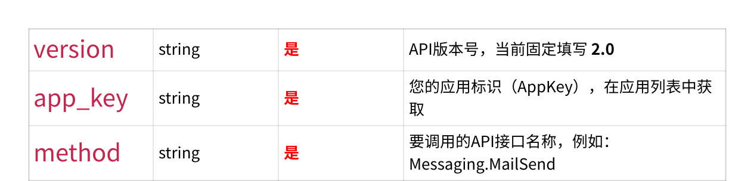

6. 应用级参数详解  
应用级参数是您的业务数据，需要经过以下步骤处理：1. 将业务参数组织成符合 JSON 规范的格式​

2. 使用 app_secret 作为密钥，对 JSON 字符串进行 AES 加密​3. 对加密后的字节数据进行 Base64 编码​  
4. 将编码后的字符串作为 HTTP Body 发送​

|  |  |
| --- | --- |
| • | 加密算法说明 |

加密算法：AES/CBC/PKCS5Padding  
初始化向量（IV）：长度为 16 的空字节数组（即：  
\0\0\0\0\0\0\0\0\0\0\0\0\0\0\0\0 ）  
加密密钥：使用您的 app_secret （长度必须为 16 或 32 字节）​字符编码：UTF-8​

测试示例：  
测试密钥：1234567890123456  
原始文本：

|  |
| --- |
| abcdefghigklmnopqrstuvwxyz0123456789 |

加密后的 Base64 结果：​

|  |
| --- |
| 8Z3dZzqn05FmiuBLowExK0CAbs4TY2GorC2dDPVlsn/tP+VuJGePqIMv1uSaVErr |

提示：如果您的加密结果与上述结果一致，说明加密实现正确。

5. 发送 HTTP 请求​  
将加密后的应用级参数作为 HTTP Body，通过 POST 方式发送到完整的 API 地址。​ ⚠️ 重要：HTTP 请求头设置​  
 请求时必须设置以下 HTTP Header：​  
 Content-Type: text/plain​  
完整调用示例：  
 步骤 1：准备参数​

|  |  |
| --- | --- |
| ◦ ◦ ◦ | 📌 接口名称：Messaging.MailSend​📌 app_key：99999​ 📌 app_secret：08212a1694c64992​ |

步骤 2：准备业务参数（JSON 格式）​  
{​

|  |
| --- |
| "DisplayName": "一起飞团队",​ |

"To": "[xxxx@163.com](mailto:xxxx@163.com)",​

|  |
| --- |
| "Subject": "邮件测试",​ |

|  |
| --- |
| "Body": "xxxxxxx" |

}​  
 步骤 3：加密并编码​  
 使用 app_secret（08212a1694c64992 ）作为密钥，对上述 JSON 进行 AES 加密，再进行 Base64 编码，得到：​

vDUMMYIpg+c1Idzbnwt0JLOXc7jhkLSlH/Bd8k2TqQSMIzbHLOJwtU05T8sjobCHNL21lzWp X7FaELY8dcfhxpb5/fzrnXYIXSYfJUEzqG25TcDCI8W1xhhc7Dl0UGCaWkLA/+7c0J/Cwb+GGUSnE MPGl8BnyTmptS78EmmpITA=​  
 步骤 4：发送 HTTP POST 请求​  
 请求 URL：​

[https://bizapi.yiqifei.cn/servings?](https://bizapi.yiqifei.cn/servings?version=2.0&app_key=99999&method=Messaging.MailSend)

[version=2.0&app_key=99999&method=Messaging.MailSend](https://bizapi.yiqifei.cn/servings?version=2.0&app_key=99999&method=Messaging.MailSend)​ 请求 Header：​

|  |
| --- |
| Content-Type: text/plain​ |

Accept-Encoding: gzip, deflate​  
请求 Body：​

vDUMMYIpg+c1Idzbnwt0JLOXc7jhkLSlH/Bd8k2TqQSMIzbHLOJwtU05T8sjobCHNL21lzWp X7FaELY8dcfhxpb5/fzrnXYIXSYfJUEzqG25TcDCI8W1xhhc7Dl0UGCaWkLA/+7c0J/Cwb+GGUSnE MPGl8BnyTmptS78EmmpITA=​  
6. 响应结果

API 调用后会返回 JSON 格式的响应数据，包含以下字段：​

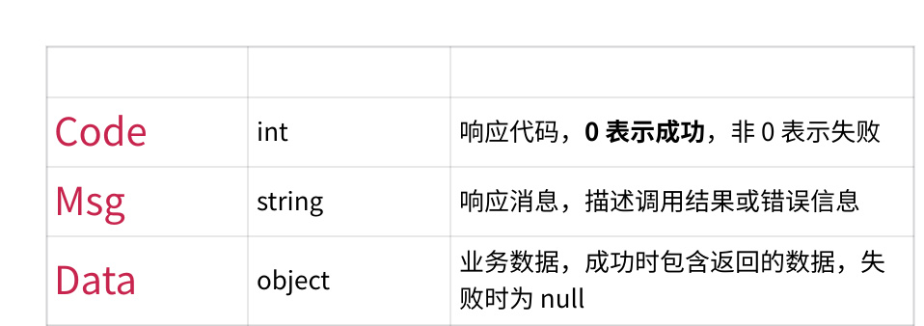

✅ 成功响应示例：​

{​  
 "Code": 0,​  
 "Msg": "调用成功",​  
 "Data": {​  
 // 返回的业务数据​  
 ...​

}​

}​

❌ 错误响应示例：​

{​

|  |
| --- |
| "Code": 1001,​ |

|  |
| --- |
| "Msg": "参数错误",​ |

|  |
| --- |
| "Data": null​ |

}​

7. 重要注意事项

|  |  |
| --- | --- |
|  | 📝 字符编码：所有的请求和响应数据编码均为 UTF-8 格式​ |
| ◦ |
| ◦ |
| 🗜️ 数据压缩：服务器支持 gzip、deflate 压缩编码，可通过设置 HTTP Header Accept- |

Encoding: gzip, deflate 启用压缩，减少传输数据量​

|  |  |
| --- | --- |
| ◦ ◦ ◦ ◦ ◦ | 🔒 密钥安全：请妥善保管 app_secret，切勿在客户端代码中硬编码或泄露​🔑 请求头设置：必须设置 Content-Type 为 text/plain，否则请求将失败​ ⏱️ 请求超时：建议设置合理的请求超时时间（推荐 30 秒）​ 🔄 重试机制：对于网络异常或超时错误，建议实现自动重试机制（最多重试 3 次）​📊 错误处理：请根据返回的 Code 和 Msg 进行相应的错误处理​ |

1. 接口列表​

|  |  |  |
| --- | --- | --- |
| 序号​ | 接口名​ | 接口说明​ |
| 1​ | ShoppingServer.EasyShopping_V2​ | 机票查询接口​ |
| 2​ | ShoppingServer.VerifyPriceServing​ | 机票验价接口​ |
| 3​ | OpenAPI.CreateOrder​ | 下单接口​ |
| 4​ | OpenAPI.SubmitOrder​ | 确认提交订单​ |
| 5​ | OpenAPI.VerifyCabin​ | 验舱并补位接口​ |
| 6​ | OpenAPI.GetOrderList​ | 获取订单详情接口​ |
| 7​ | ShoppingServer.PNRCancelByPSONr​ | 取消PNR接口​ |
| 8​ | ShoppingServer.AirReshopServing​ | 改期航班查询​ |
|  |  |  |

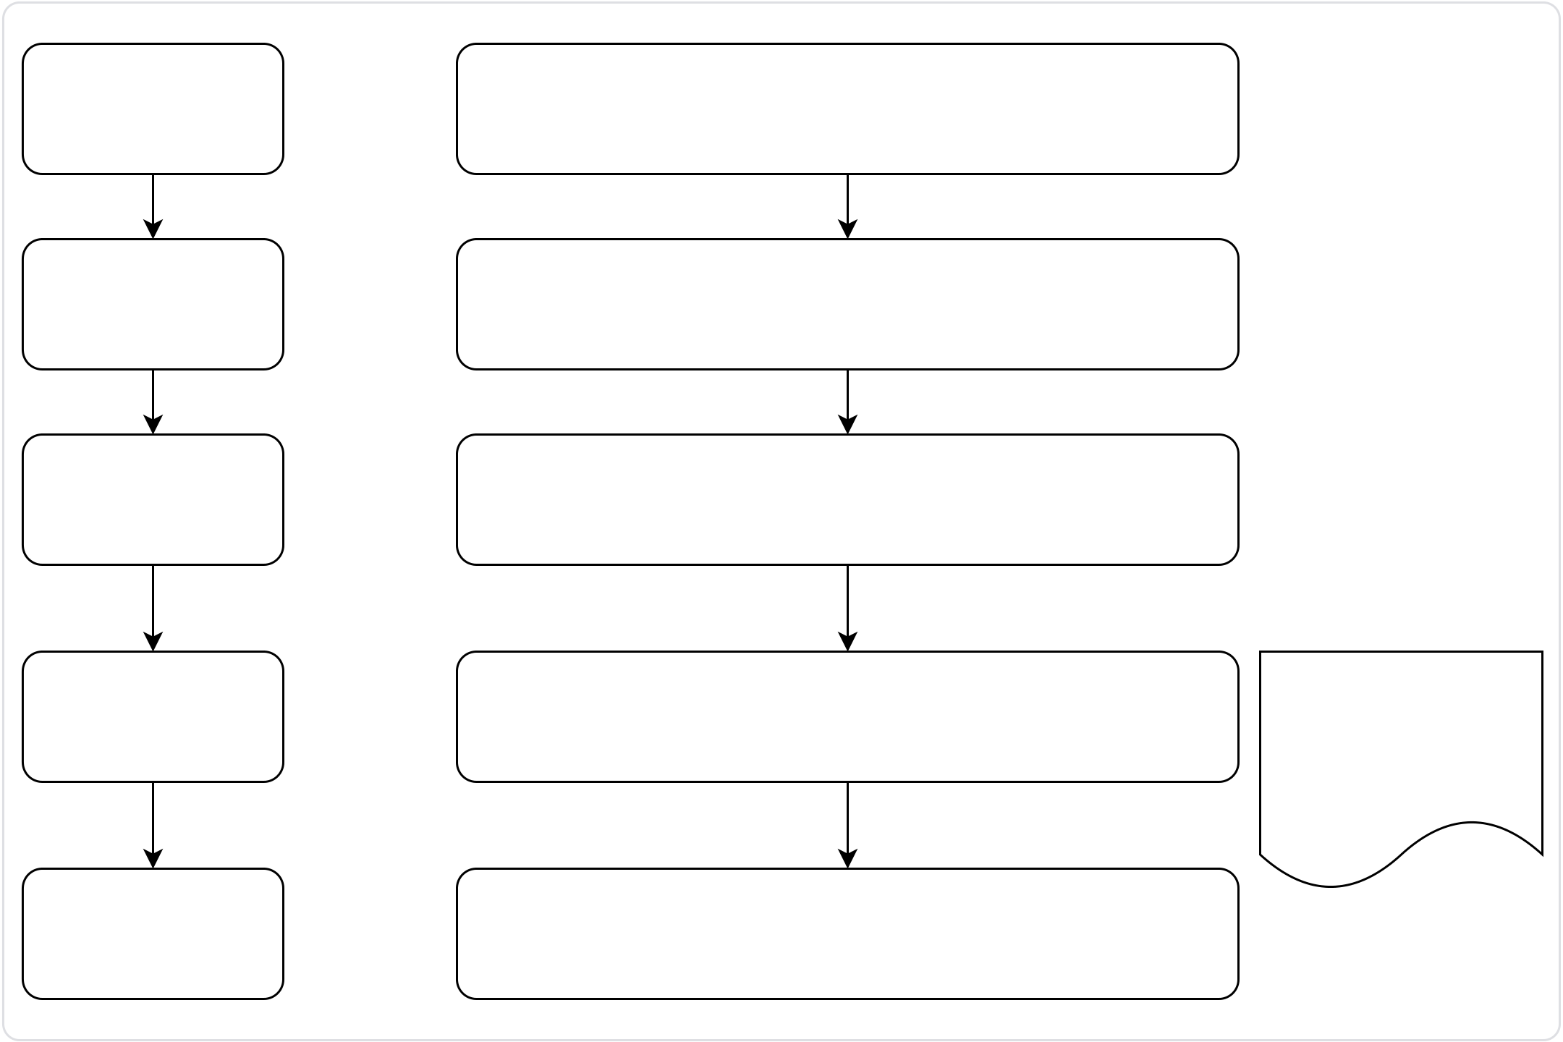

|  |  |  |
| --- | --- | --- |
| 9​ | ShoppingServer.AirRefundPriceServing​ | 查询退票费​ |
| 10​ | FareRuleServer.GetFareRule ​ | 获取退改条款​ |
| 11​ | OpenAPI.Dest.GetAirportList​ | 目的地列表​ |

2. 业务流程图​

国际机票查询，预订、确认出票流程

调用

|  |  |
| --- | --- |
| 用户输入查询条件 | BizApi.OpenAPI.Shopping.EasyShopping_V2 |

调用

|  |  |
| --- | --- |
| 选择航班 | BizApi.AirTickets.Shopping.VerifyPriceServing |

调用  
  
填写资料

|  |  |  |
| --- | --- | --- |
| 下单 | BizApi.OpenAPI.CreateOrder | 用户下单后到支付有时 |
| 调用 |
| 用户发起支付 | BizApi.OpenAPI.Shopping.VerifyCabin | 间差，在这个过程有可 |
| 能座位被航空公司取 |

消，支付前需要再核验  
一次座位是否可用。

调用  
支付成功  
 BizApi.OpenAPI.SubmitOrder

国际机票改期流程

选择需要变更的票号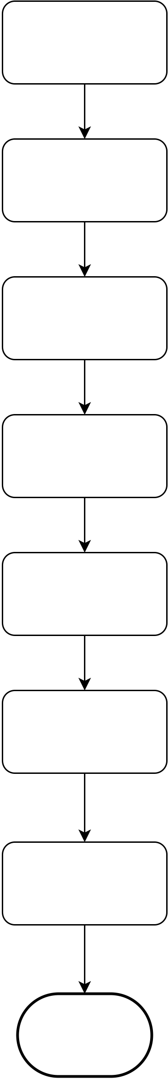

选择需变更航段

|  |  |
| --- | --- |
| 改期航班查询 | BizApi.OpenAPI.Shopping.AirReshopServing |

选择新航段

|  |  |
| --- | --- |
| 改期费校验 | BizApi.HBTrips.GetVerifyAirReshopServing |

|  |  |
| --- | --- |
| 提交改期 | BizApi.OpenAPI.CreateChangeOrder |

|  |  |
| --- | --- |
| 确认出票 | BizApi.OpenAPI.SubmitOrder |

|  |  |
| --- | --- |
| 回调或刷新 | BizApi.HBTrips.Order.GetOrderList |

改期新票号

对接方提交接口接收改期票号推送

退票流程

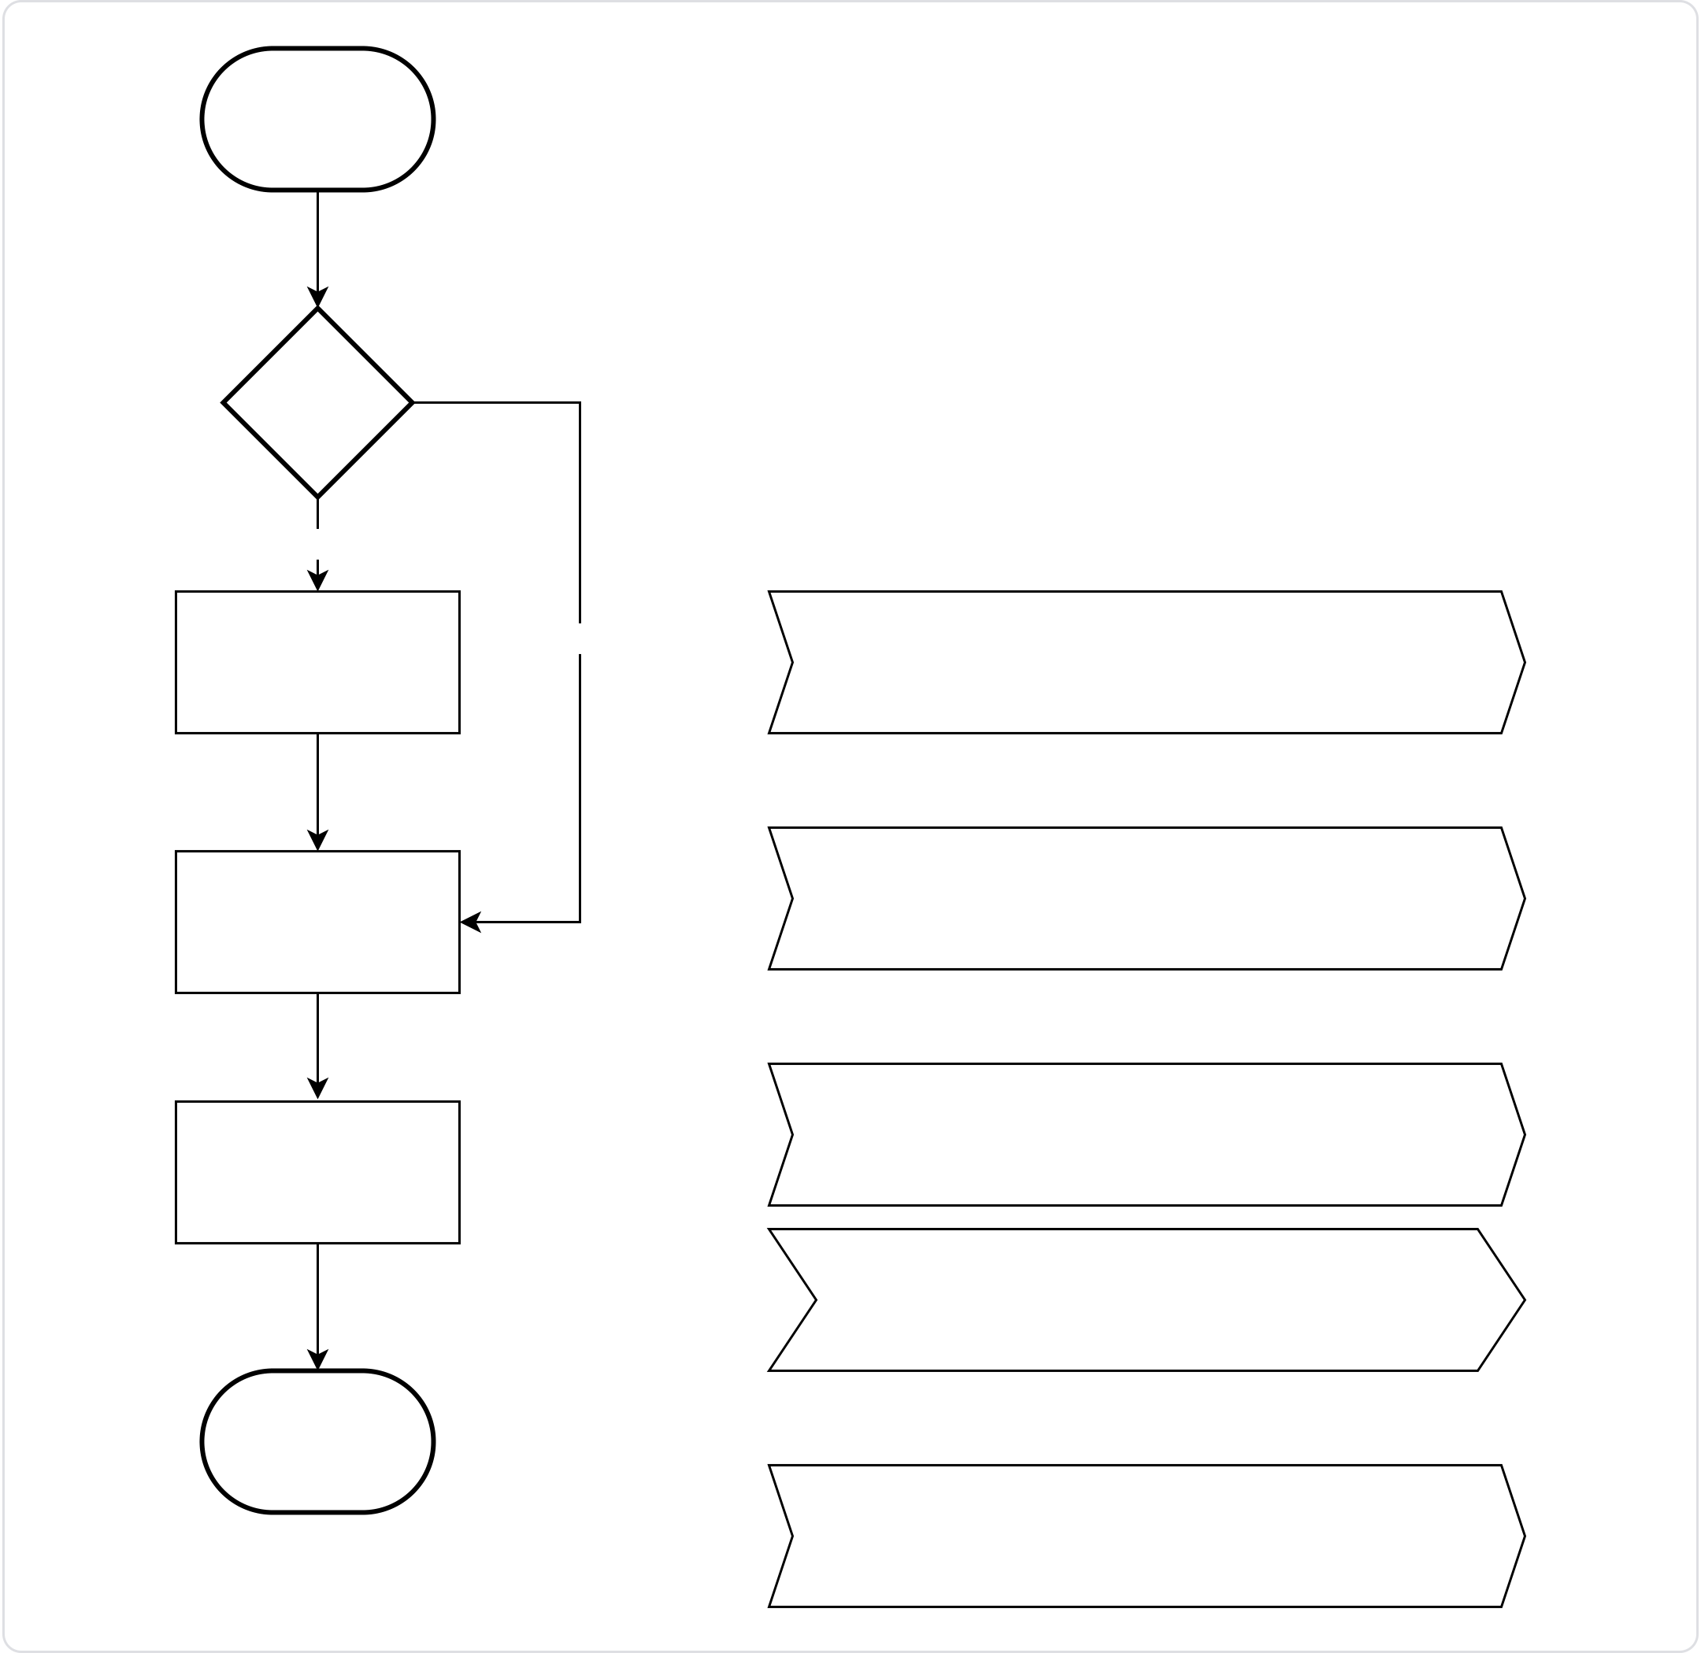

选择需退票票号

自愿/非自愿  
  
退票

自愿

|  |  |  |
| --- | --- | --- |
| 查询退票费 | 非自愿 | BizApi.AirTickets.Shopping |
| .AirRefundPriceServing |
| 提交退票单 | BizApi.OpenAPI.CreateReturnOrder |

BizApi.OpenAPI.SubmitOrder确认退票

BizApi.HBTrips.Order.GetOrderList

回调退票状态  
  
和费用

对接方提交接口接收退票状态推送

3. 接口说明​

1. BizApi.OpenAPI.Shopping.EasyShopping_V2​

请求参数

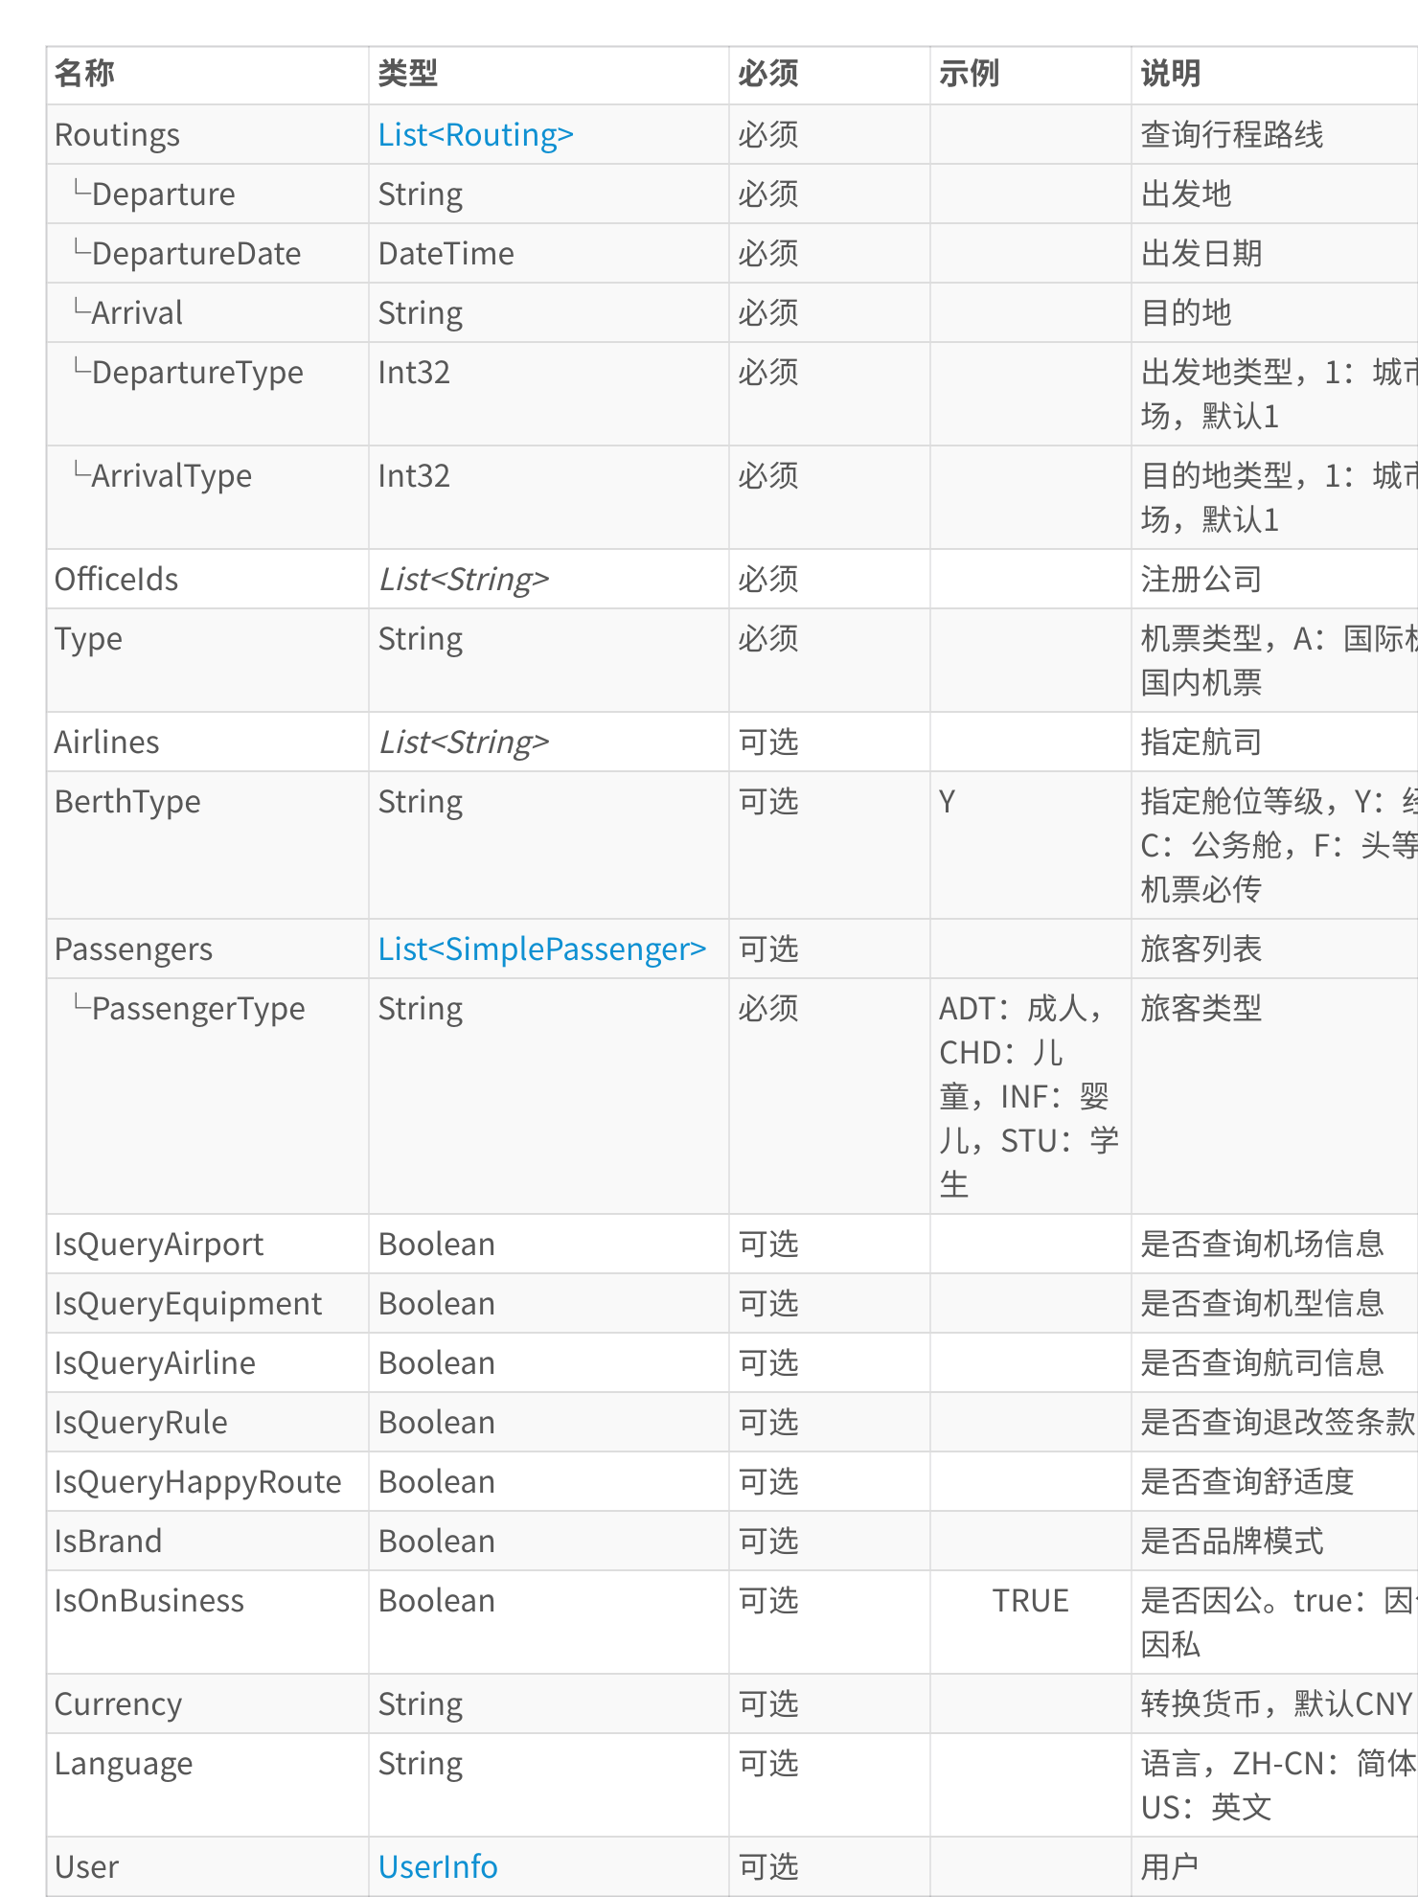

|  |  |
| --- | --- |
| 💡 | {​ |

"Passengers": [​  
 {​  
 "PassengerType": "ADT"​  
 }​  
 ],​  
 "OnlyDirectFlight": false,  
 "BerthType": "Y",​  
 "IsQueryRule": false,​  
 "IsQueryAirline": false,​  
 "CodeShare": false,​  
 "IsQueryAirport": false,​  
 "Routings": [​  
 {​  
 "Departure": "CAN",​  
 "Arrival": "SIN",​  
 "ArrivalType": 1,​  
 "DepartureDate": "2023-03-27",​  
 "DepartureType": 1​  
 },​  
 {​  
 "Departure": "SIN",​  
 "Arrival": "CAN",​  
 "ArrivalType": 1,​  
 "DepartureDate": "2023-03-30",​  
 "DepartureType": 1​  
 }​  
 ],​  
 "Type": "A",​  
 "ChildQty": 0,​

|  |
| --- |
| "Currency": "CNY",​ |

|  |
| --- |
| "IsQueryEquipment": true,​ |

|  |
| --- |
| "OfficeIds": [​ |

|  |
| --- |
| "EI00D"​ |

|  |
| --- |
| ]​ |

|  |
| --- |
| }​ |

响应参数

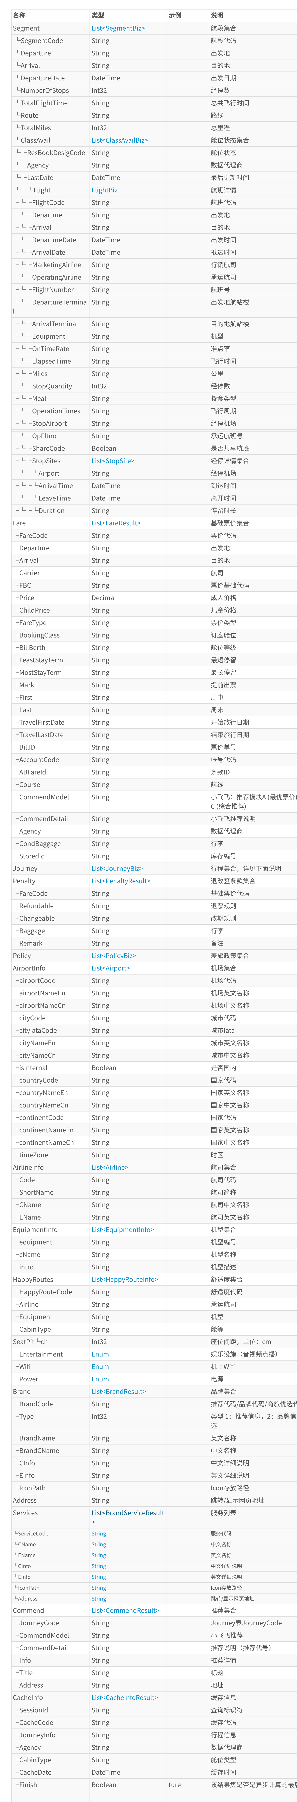









JourneyBiz​

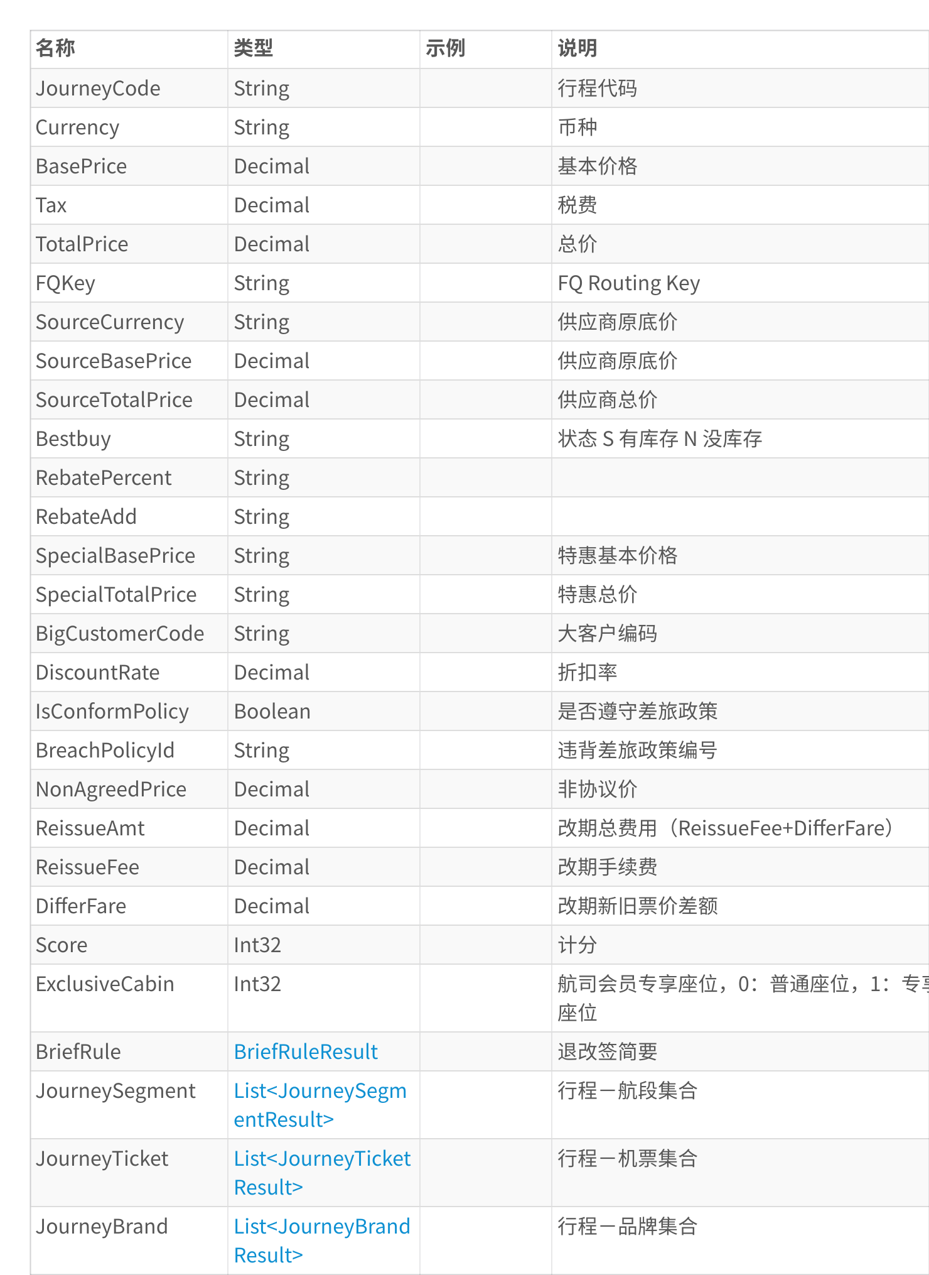

BriefRuleResult​

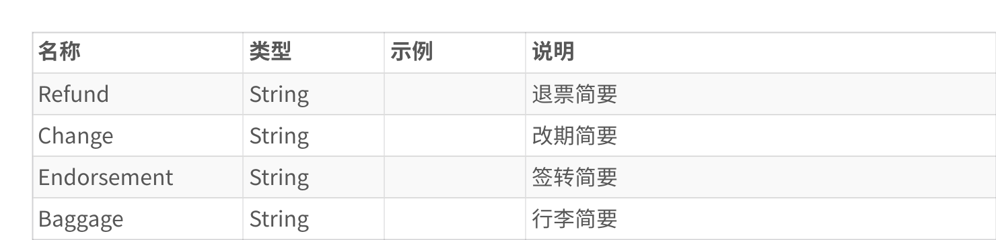

JourneySegmentResult​

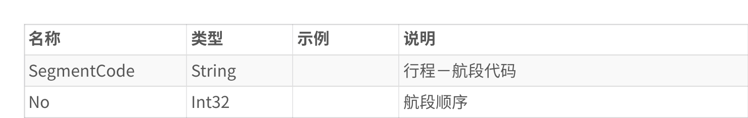

JourneyTicketResult​

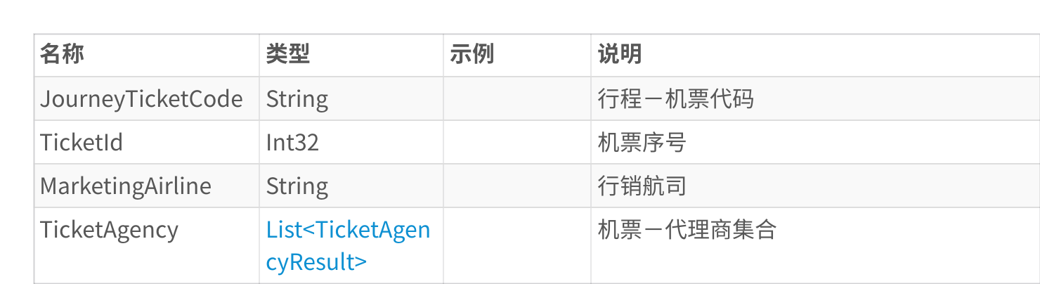

TicketAgencyResult​

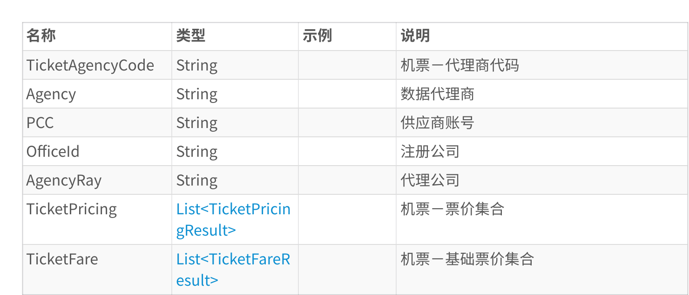

TicketPricingResult​

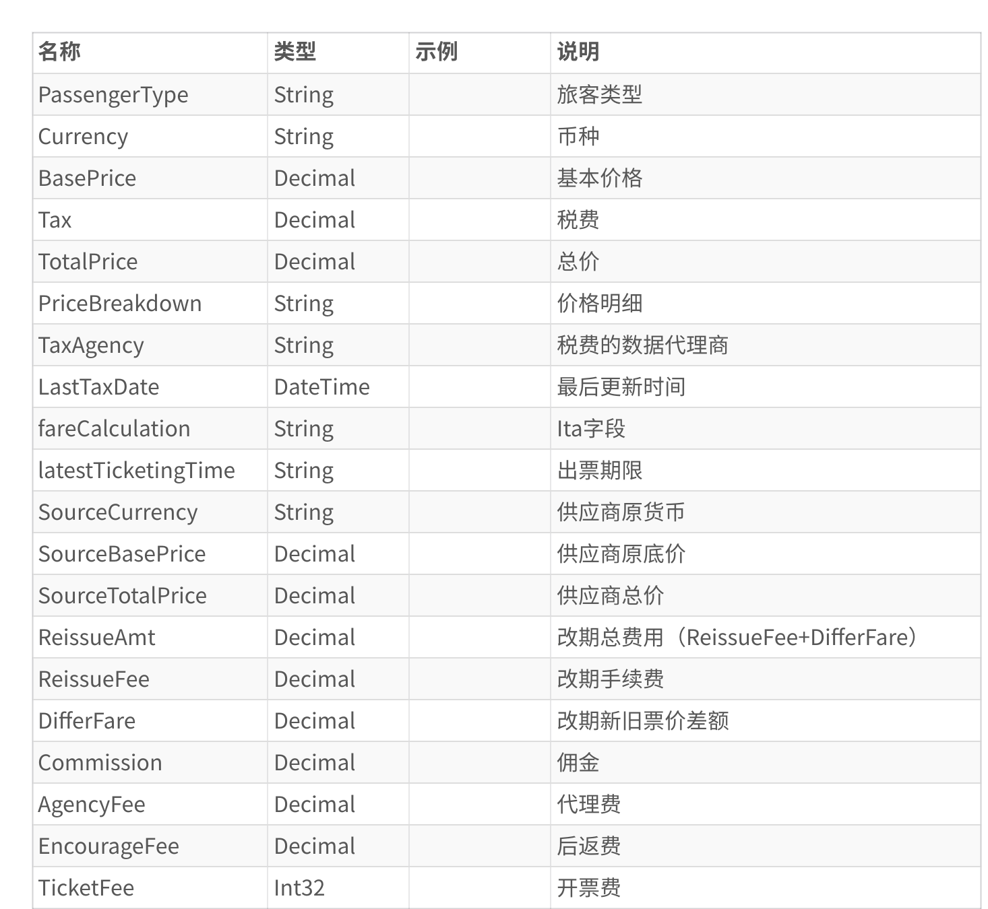

TicketFareResult​

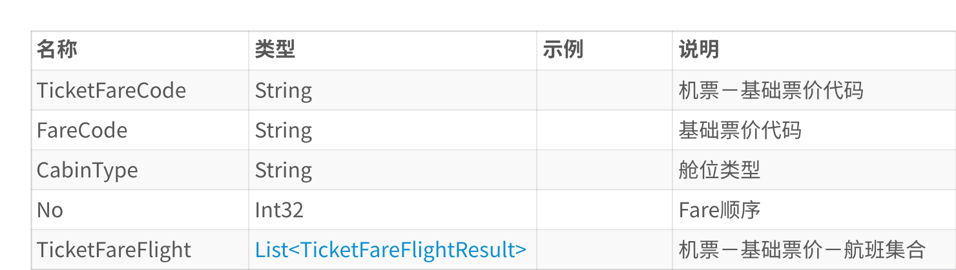

TicketFareFlightResult​

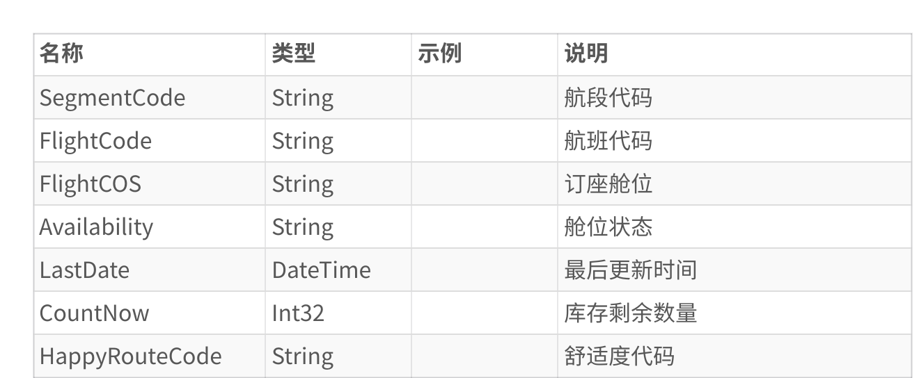

JourneyBrandResult​

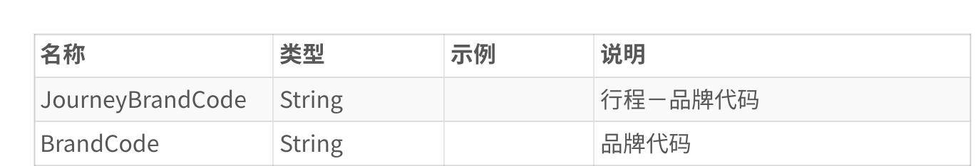

2. BizApi.AirTickets.Shopping.VerifyPriceServing 验价​

应用场景：预订前验价和验舱

请求参数

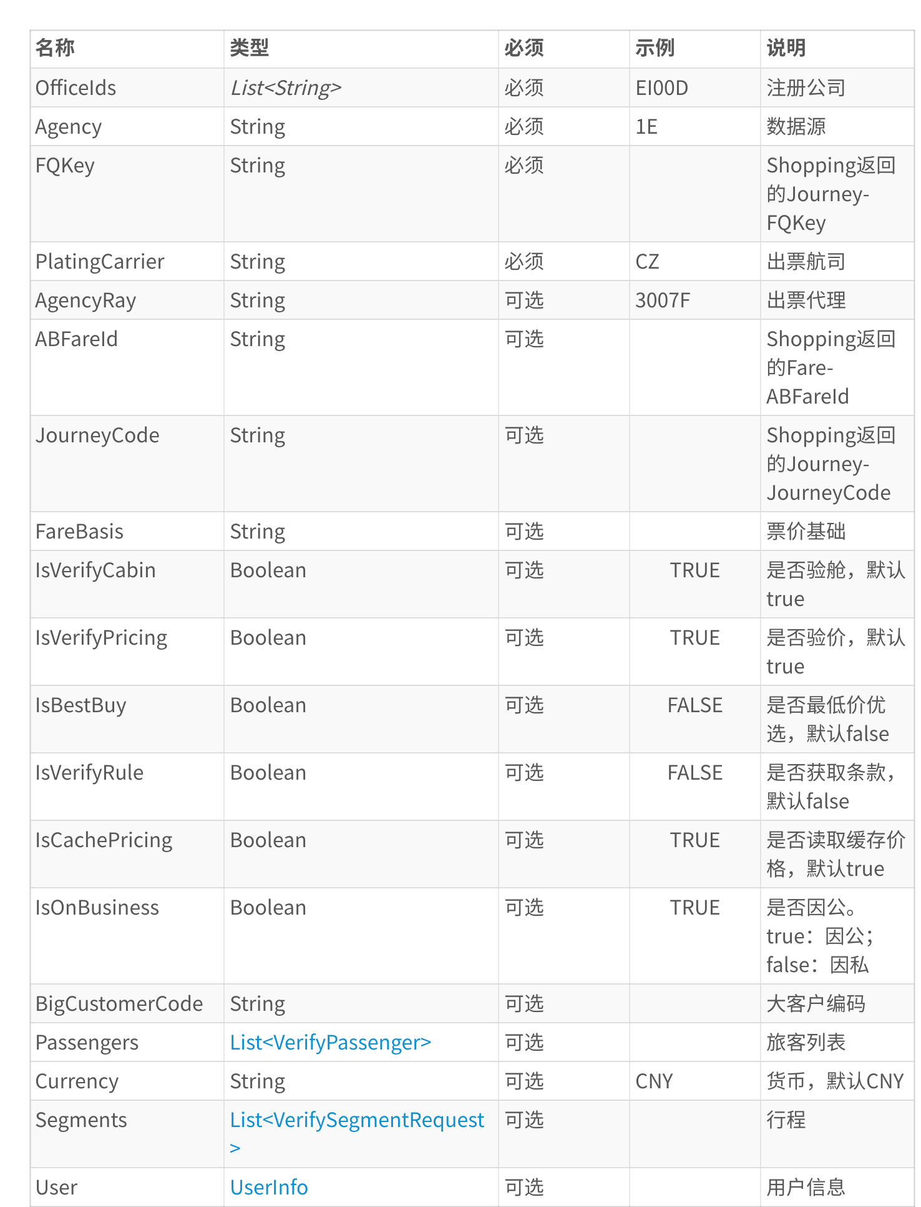

VerifyPassenger​

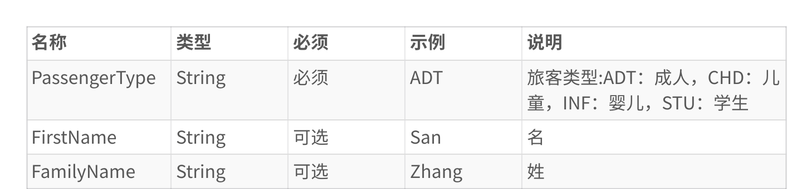

VerifySegmentRequest​

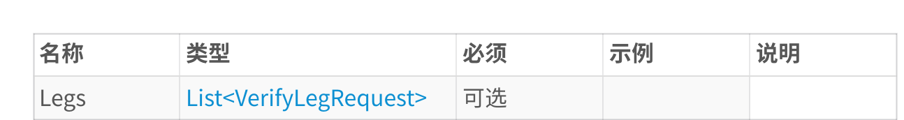

VerifyLegRequest​

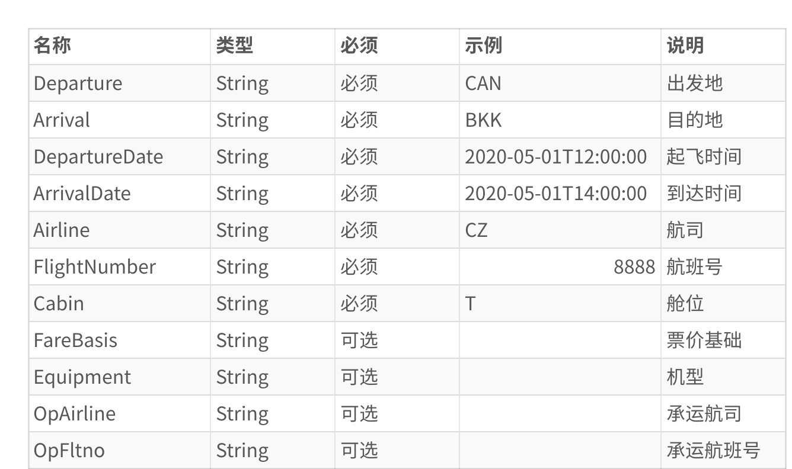

|  |  |
| --- | --- |
| 代码块​ | |
| 1 | { |
| 2 | "ABFareId": "A|CAN|SIN|MU|NKE0WBLL|2023-01- |

23T00:00:00|key(RuleTariff::Rule::OWRT::Routing::Footnote1::Footnote2::Passenge rType::FareType::OriginAddonTariff::OriginAddonFootnote1::OriginAddonFootnote2: :DestinationAddonTariff::DestinationAddonFootnote1::DestinationAddonFootnote2:: TravelAgencyCode::IataNumber::DepartmentCode::Origin::Destination::FareSource:: FbrBaseTariff::FbrBaseRule::AccountCode::FbrBaseFareBasis::OriginAddonRouting:: DestinationAddonRouting::R3c025TblNo)|008::CSL1::1::0202::::::ADT::PRU::008::::

|  |  |
| --- | --- |
| 3 | ::::::::CAN131::08015545::::CAN::SIN::ATPCO::::::::::0303::::", "IsVerifyCabin": true, |

4 "FQKey":   
"H4sIAAAAAAAAA52RX3OiMBTFv0te124TURBm9gFiVRBQhz+d3Z19QAgWi9AGkGD1uzdB68M+luGBe3 POuT9yP8CaZjGpgPb3A6yjqiLFjlC/eyNAA/rUBwOAG0pJEXe8gd3fvOGVDY2JEVWk9wJtqED4Ew6AH zGgyaoivvsjg5LoNSnbAmhFk+eXf1xzi+Y5s4iKlKya5dnupb4y3Jtc5C6f4LNh21yrZzTPCuF0AmHt HW5z2BLKe2NlBHl3St4iWjdUyLDuChul2THKeb105qI2RL6ZCIIzl5w90z07wflr0nkIh9IDRA9DyYd Q619wGXwTS5UR+g/rhnHH4vO/jcVv0+KrKEiHy0SED2NJjuVUGm0hQiRRI1lJUaqOJzLZKtJ4yyet86 jOih2OOEHP2HPru9uC0ZPQYHy9QCQJfCPb4aaqywOh1zlilQOwSlNCzem9rF94WaQlty5Glal/PYrLv I4t1ZjZHYpNfMRt6FtBRR3Lw23jV8j2O7h895g59Zh7wkfLXuZB7IzX3jYM42JjBaG9qUVOxlYGEWcn 155AWoVB5+zjNphZrZ3Bd49n0XJTJsfINnC16jzVOum5RU2dutSBTA6e/+D9ZuKw7HWhs3n9uDqpx9B

|  |  |
| --- | --- |
| 5  6  7  8  9  10  11  12  13  14  15  16  17  18  19  20  21  22  23  24  25  26  27  28  29  30  31  32  33  34  35  36  37  38  39  40  41 | 0TxabJPMFCuJ9OHFmm+m4a0c6Lh8P5o/+V36ByyeoXHyCKwMAAA==", "Currency": "CNY",  "JourneyCode": "2c36c6f34b011ed9a67f1f9586eb735b", "IsVerifyPricing": true,  "PlatingCarrier": "MU",  "Segments": [  {  "Legs": [  {  "FareBasis": "NKE0WBLL",  "ArrivalDate": "2023-01-24 01:00:00",  "Departure": "CAN",  "Arrival": "KMG",  "Airline": "MU",  "FlightNumber": "5740",  "OpAirline": "",  "DepartureDate": "2023-01-23 22:20:00",  "Equipment": "73L",  "Cabin": "B",  "OpFltno": "5740"  },  {  "FareBasis": "NKE0WBLL",  "ArrivalDate": "2023-01-24 15:00:00",  "Departure": "KMG",  "Arrival": "SIN",  "Airline": "MU",  "FlightNumber": "9611",  "OpAirline": "",  "DepartureDate": "2023-01-24 10:40:00",  "Equipment": "73L",  "Cabin": "N",  "OpFltno": "9611"  }  ]  }  ],  "OfficeIds": [ |

|  |  |  |  |
| --- | --- | --- | --- |
| 42  43  44  45  46  47  48  49  50  51  52 | |  | | --- | | "EI00D" |   ],  "IsBestBuy": false,  "Agency": "1E",  "Passengers": [  {  "PassengerType": "ADT"  }  ],  "IsVerifyRule": false   |  | | --- | | } | |
|  | |

响应结果

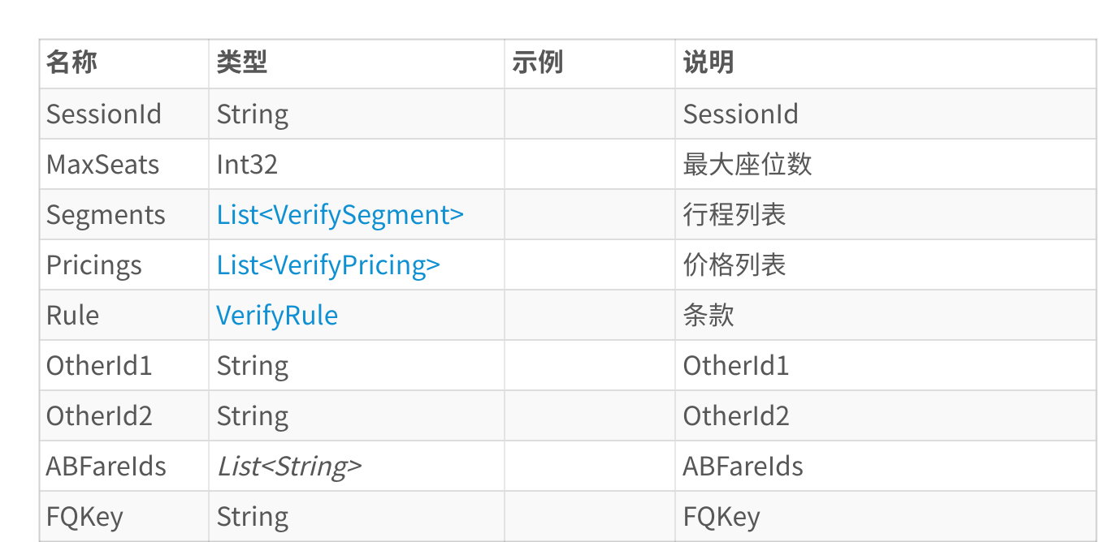

VerifySegment​

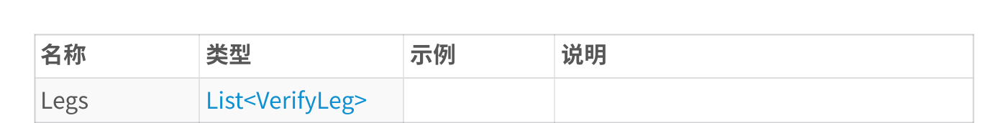

VerifyLeg​

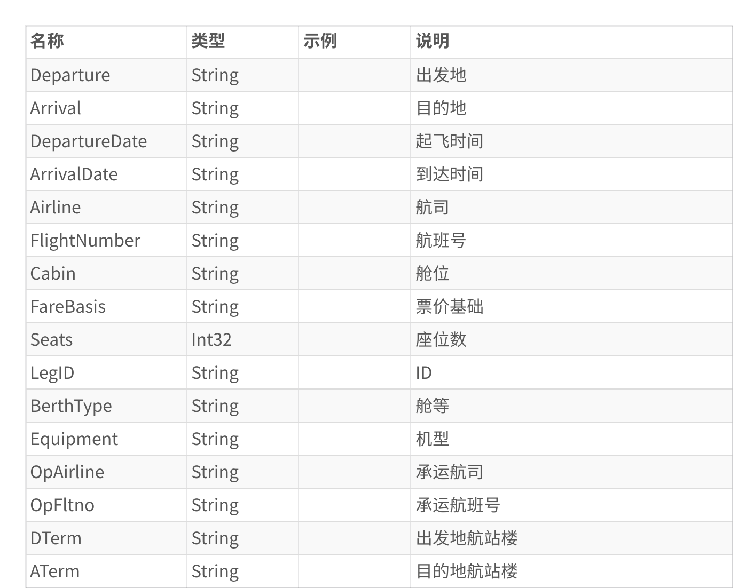

VerifyPricing​

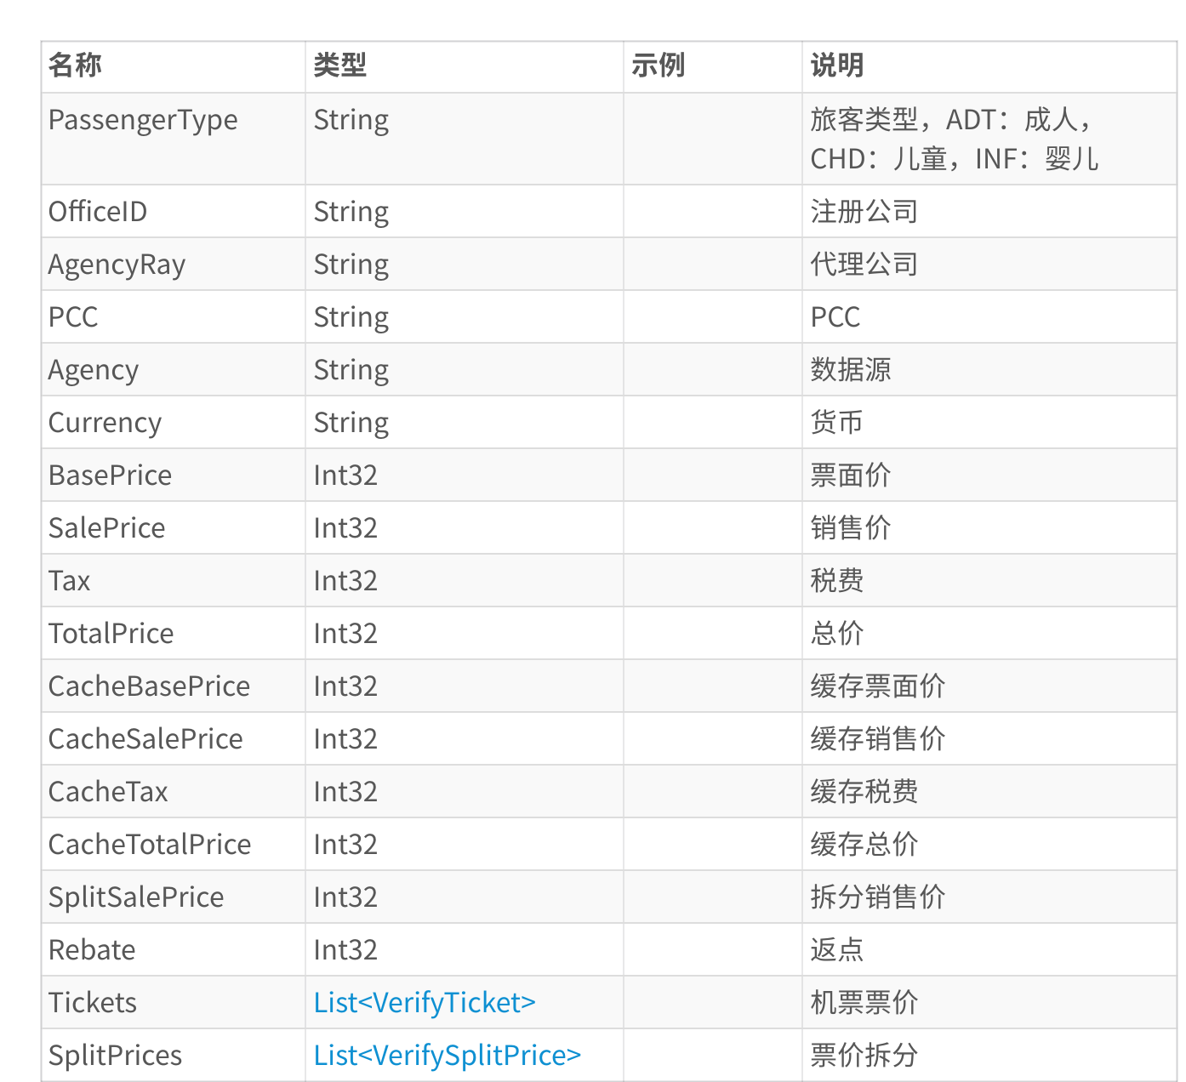

VerifyTicket​

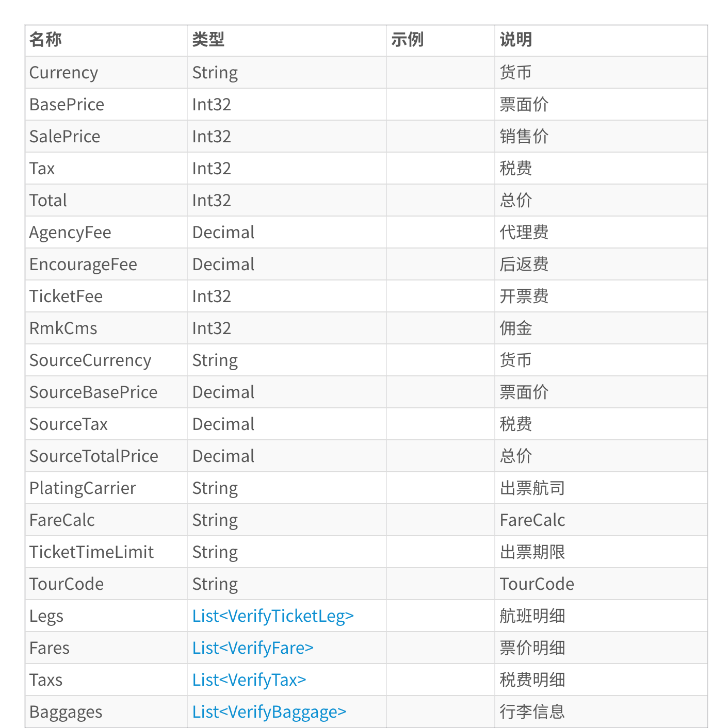

VerifyTicketLeg​

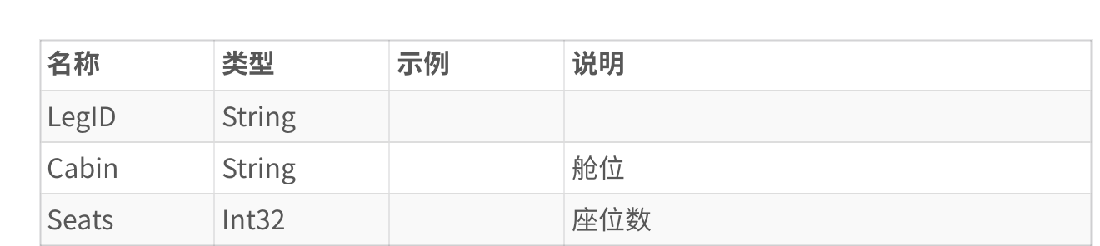

VerifyFare​

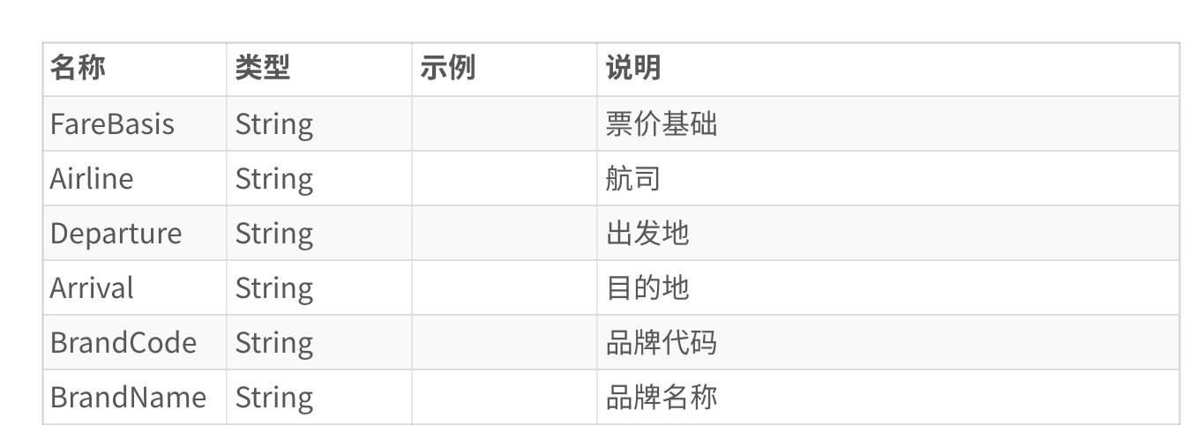

VerifyTax​

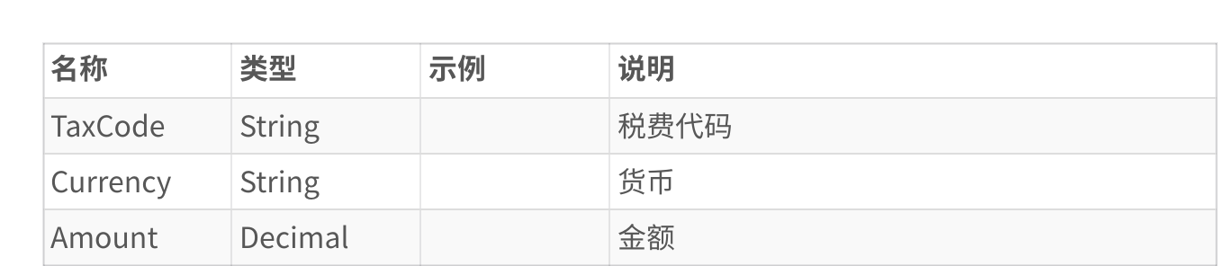

VerifyBaggage​

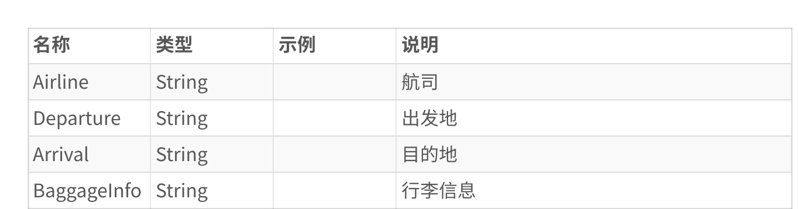

VerifySplitPrice​

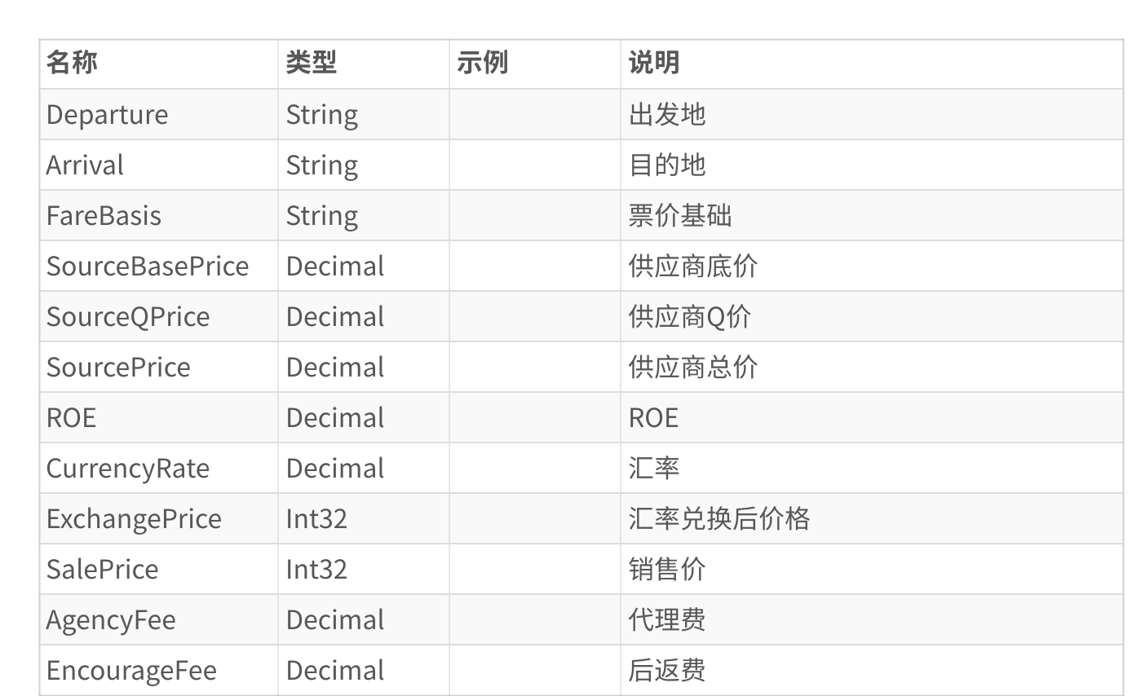

3. BizApi.OpenAPI.Easy.AICreateOrder​

接口说明: AI智能创建订单接口，支持机票、酒店、火车票、保险、签证、欧铁等多种产品类型的订单

创建

接口类型: POST​

请求参数

主要参数

|  |  |  |  |
| --- | --- | --- | --- |
| 参数名​ | 类型​ | 必填​ | 说明​ |
| OutOrderNo​ | |  | | --- | | string | | 否​ | 外部订单号​ |
| SourceTypeID​ | |  | | --- | | integer | | ✅ 是​ | 来源ID​ |
| BookerID​ | |  | | --- | | string | | 否​ | 订票人​ |
| LRFollowCode​ | |  | | --- | | string | | 否​ | 跟单人账号：HS010102​ |
| OTVendorCode​ | |  | | --- | | string | | 否​ | 出票商​ |
| CustCompanyCode​ | |  | | --- | | string | | 否​ | 客公司编码(G端)​ |
|  |  |  |  |

|  |  |  |  |  |
| --- | --- | --- | --- | --- |
| PayCompanyCode​ | |  | | --- | | string | | 否​ | 支付公司编码​ |
| RecordID​ | |  | | --- | | string | | 否​ | 记录ID​ |
| TravelNatureCode​ | |  | | --- | | string | | 否​ | 差旅性质(因公-Public,因私-Private)​ |
| PaymentMethodID​ | |  | | --- | | integer | | ✅ 是​ | 1-现付，3-欠款，5-月结​ |
| SettlementTypeID​ | |  | | --- | | integer | | ✅ 是​ | 支付方式ID，1-欠条，2-现金，3-刷卡，4-汇款，8-一起飞收款宝，9-公司卡支付，10-无卡支付，11-网上支付​ |
| Remark​ | |  | | --- | | string | | 否​ | 备注​ |
| CostCenters​ | |  | | --- | | Array<AICostCe |  |  | | --- | | nter> | | 否​ | 成本中心分摊金额信息​ |
| Products​ | |  | | --- | | Array<AIProdu |  |  | | --- | | ct> | | ✅ 是​ | 产品单信息​ |
| Passengers​ | |  | | --- | | Array<AIPasse |  |  | | --- | | nger> | | ✅ 是​ | 乘机人/被保人/主入住人信息​ |
| ContactInfo​ | |  | | --- | | Object<EContac |  |  | | --- | | tInfo> | | ✅ 是​ |  |
| DeliveryInfo​ | |  | | --- | | Object<Deliver |  |  | | --- | | yInfo> | | 否​ |  |
| ExtraExpense​ | |  | | --- | | Object<ExtraEx |  |  | | --- | | pense> | | 否​ |  |

产品类型说明

ProductCategoryID 产品大类枚举：​

|  |  |
| --- | --- |
| 产品ID​ | 产品类型​ |
| 2​ | 酒店​ |
| 3​ | 火车票​ |
| 4​ | 保险​ |
| 5​ | 签证​ |
|  |  |

|  |  |
| --- | --- |
| 8​ | 国内机票​ |
| 9​ | 国际机票​ |
| 10​ | 欧铁点到点​ |
| 11​ | 欧铁通票​ |
| 725​ | 租车​ |
| 796​ | 旅游产品​ |
| 809​ | 用车​ |

请求对象定义

接口定义了 20 个请求对象。

AIProduct​

|  |  |  |  |
| --- | --- | --- | --- |
| 参数名​ | 类型​ | 必填​ | 说明​ |
| ProductCategoryID​ | |  | | --- | | integer | | ✅ 是​ | 产品大类：8-国内机票，9-国际机票，4-保险，2-酒店，3-火车票，809-用车​ |
| SubProductCategoryID​ | |  | | --- | | integer | | 否​ | 产品子类​ |
| GDSCode​ | |  | | --- | | string | | ✅ 是​ | GDSCode，必填​ |
| PublicAmount​ | |  | | --- | | number | | 否​ | 对公应付金额​ |
| PrivateAmount​ | |  | | --- | | number | | 否​ | 对私应付金额​ |
| BizPolicy​ | |  | | --- | | Object<AIBizPolicy |  |  |  | | --- | --- | | |  | | --- | | > | | | 否​ |  |
| Air​ | |  | | --- | | Object<AIAirTicket |  |  |  | | --- | --- | | |  | | --- | | > | | | 否​ |  |
| Insurance​ | |  | | --- | | Object<AIInsurance |  |  |  | | --- | --- | | |  | | --- | | > | | | 否​ |  |
| Hotel​ | |  | | --- | | Object<AIHotel> | | 否​ |  |
| Train | |  | | --- | | Object<AITrain> | | 否​ |  |
| Ship​ | |  | | --- | | Object<AIShip> | | 否​ |  |
|  |  |  |  |

|  |  |  |  |  |  |  |
| --- | --- | --- | --- | --- | --- | --- |
| PassProduct​ | |  | | --- | | Object<AIEurailPAS |  |  |  | | --- | --- | | |  | | --- | | S> | | | 否​ |  |
| PTPProduct​ | |  | | --- | | Object<AIEurailPTP |  |  |  | | --- | --- | | |  | | --- | | > | | | 否​ |  |
| TravelProduct​ | |  | | --- | | Array<AITravelProd |  |  | | --- | | uct> | | 否​ | 旅游产品， ProductCategoryID=796 时，此处必填​ |
| Visa​ | |  | | --- | | Object<AIVisa> | | 否​ |  |

AIPassenger​

|  |  |  |  |
| --- | --- | --- | --- |
| 参数名​ | 类型​ | 必填​ | 说明​ |
| PassengerCode​ | |  | | --- | | string | | 否​ | 乘客人员编码​ |
| LastName​ | |  | | --- | | string | | 否​ | 姓​ |
| FirstName​ | |  | | --- | | string | | 否​ | 名​ |
| PassengerTypeCode​ | |  | | --- | | string | | 否​ | 乘客类型：ADT-成 人,CHD-小孩,INF-婴儿​ |
| IDTypeCode​ | |  | | --- | | string | | 否​ | 签证的身份类型【在职人员 SOP，自由职业  FSP，退休人员 RSP，在校学生 SIS，学龄前儿童 PCH】,默认在职人员，多个不同的身份类型下单 时，此处必填​ |
| Birthday​ | |  | | --- | | string (date-time) | | 否​ | 生日，格式：YYYY-MM-DD，非身份证必填，酒店含儿童也必填​ |
| Gender​ | |  | | --- | | string | | 否​ | 乘客性别：M-男，F-女​ |
| CertTypeCode​ | |  | | --- | | string | | 否​ | 证件类型：10 = 军人证，11 = 回乡证，12 = 台胞证，13 = 港澳通行证，ID = 身份证，NI = 其他证 件，PP = 护照,14=户口本 15 =出生证明 16=士兵证​ |
|  |  |  |  |

|  |  |  |  |  |
| --- | --- | --- | --- | --- |
| CertNr​ | |  | | --- | | string | | 否​ | 证件号码​ |
| CertValid​ | |  | | --- | | string (date-time) | | 否​ | 证件有效日期，非身份证必填​ |
| Nation​ | |  | | --- | | string | | 否​ | 乘客国籍，国家二字码，默认CN​ |
| CertIssue​ | |  | | --- | | string | | 否​ | 证件发行国家，国家二字码，默认CN​ |
| Mobile​ | |  | | --- | | string | | 否​ | 手机​ |
| InsFQKey​ | |  | | --- | | string | | 否​ | 投保的产品FQKey，有保险产品时，此处必填​ |
| TicketNo​ | |  | | --- | | string | | 否​ | 投保的票号(航意险 此处必填)​ |
| InsFlights​ | |  | | --- | | Array<AIInsFlight> | | 否​ | 投保的航班(航意险 此处必填)​ |

EContactInfo​  
说明: 联系人信息​

|  |  |  |  |
| --- | --- | --- | --- |
| 参数名​ | 类型​ | 必填​ | 说明​ |
| Name​ | |  | | --- | | string | | ✅ 是​ | 联系人姓名​ |
| Email​ | |  | | --- | | string | | 否​ | 邮箱,联系方式必填其一​ |
| Mobile​ | |  | | --- | | string | | ✅ 是​ | 手机,联系方式必填其一​ |

AIAirTicket​  
说明: 机票产品，ProductCategoryID=8/9时，此处必填​

|  |  |  |  |
| --- | --- | --- | --- |
| 参数名​ | 类型​ | 必填​ | 说明​ |
| FQKey | |  | | --- | | string | | ✅ 是​ | FQKey，来源于机票验价接口，必填​ |
| ABFareId​ | |  | | --- | | string | | 否​ | ABFareId，来源于机票验价接口​ |
| TripType​ | |  | | --- | | integer | | 否​ |  |

|  |  |  |  |
| --- | --- | --- | --- |
|  |  |  | 行程类型： 1=去程，2=回程​ |

AIHotel​  
说明: 酒店产品，ProductCategoryID=2时，此处必填​

|  |  |  |  |
| --- | --- | --- | --- |
| 参数名​ | 类型​ | 必填​ | 说明​ |
| FQKey | |  | | --- | | string | | ✅ 是​ | 对应酒店RateCode​ |
| GuestRemarks​ | |  | | --- | | string | | 否​ | 酒店预定，客户备注​ |
| CityCode​ | |  | | --- | | string | | 否​ | 城市Code​ |
| CityName​ | |  | | --- | | string | | 否​ | 城市名称​ |
| HotelName​ | |  | | --- | | string | | 否​ | 酒店名称​ |
| CheckInDate​ | |  | | --- | | string (date-time) | | ✅ 是​ | 入住日期:yyyy-MM-dd​ |
| CheckOutDate​ | |  | | --- | | string (date-time) | | ✅ 是​ | 退房日期:yyyy-MM-dd​ |

AITrain​  
说明: 火车票产品，ProductCategoryID=3 时，此处必填​

|  |  |  |  |
| --- | --- | --- | --- |
| 参数名​ | 类型​ | 必填​ | 说明​ |
| PlatformUserName​ | |  | | --- | | string | | 否​ | 火车票12306账号，自购，必填​ |
| PlatformPassword​ | |  | | --- | | string | | 否​ | 火车票12306密码，自购，必填​ |
| Legs​ | |  | | --- | | Array<AITrainLeg> | | 否​ | 行程Fqkey，几个行程就是几条数据​ |

AIInsurance​  
说明: 保险产品，ProductCategoryID=4时，此处必填（国内机票按航班下单，国际机票下一个即可）​

|  |  |  |  |
| --- | --- | --- | --- |
| 参数名​ | 类型​ | 必填​ | 说明​ |
| EffectiveStart​ | |  | | --- | | string (date-time) | | ✅ 是​ | 生效日期​ |
|  |  |  |  |

|  |  |  |  |  |
| --- | --- | --- | --- | --- |
| EffectiveEnd​ | |  | | --- | | string (date-time) | | ✅ 是​ | 截止日期​ |
| ProductCode​ | |  | | --- | | string | | 否​ | 供应商产品代码​ |
| ProductName​ | |  | | --- | | string | | 否​ | 产品名​ |
| PlanCode​ | |  | | --- | | string | | ✅ 是​ | 供应商计划代码​ |
| DestnName​ | |  | | --- | | string | | 否​ | 目的地名称，旅游险此项必填，例：大连​ |

AIVisa​

说明: 签证产品，ProductCategoryID=5 时，此处必填​

|  |  |  |  |
| --- | --- | --- | --- |
| 参数名​ | 类型​ | 必填​ | 说明​ |
| ProductCode​ | |  | | --- | | string | | 否​ | 产品代码​ |
| VisaName​ | |  | | --- | | string | | 否​ | 签证产品名​ |
| CountryCode​ | |  | | --- | | string | | 否​ | 国家代码​ |
| DepartureDate​ | |  | | --- | | string (date-time) | | 否​ | 预计出行日期​ |

AIBizPolicy​

说明: 差旅政策和成本中心​

|  |  |  |  |
| --- | --- | --- | --- |
| 参数名​ | 类型​ | 必填​ | 说明​ |
| IsContrPolicy​ | |  | | --- | | boolean | | 否​ | 是否违背差旅政策​ |
| ContrReason​ | |  | | --- | | string | | 否​ | 违背差旅政策原因​ |
| ContrContent​ | |  | | --- | | string | | 否​ | 违背差旅政策内容，多个内容用;隔开​ |
| TravelPolicyID​ | |  | | --- | | integer | | 否​ | 差旅政策ID​ |
| TravelPurpose​ | |  | | --- | | string | | 否​ | 出差原因​ |
| CostCenterID​ | |  | | --- | | integer | | 否​ | 成本中心ID​ |
| CostCenterInfo​ | |  | | --- | | string | | 否​ | 成本中心​ |

AICostCenter​

|  |  |  |  |
| --- | --- | --- | --- |
| 参数名​ | 类型​ | 必填​ | 说明​ |
| CostCenterID​ | |  | | --- | | string | | 否​ | 分摊成本中心ID​ |
| CostCenterInfo​ | |  | | --- | | string | | 否​ | 分摊成本中心​ |
| CurrencyID​ | |  | | --- | | integer | | 否​ | 币种ID​ |
| Amount​ | |  | | --- | | number | | 否​ | 分摊金额​ |
| Percentage​ | |  | | --- | | number | | 否​ | 分摊百分比​ |

AIShip​

说明: 船票产品，ProductCategoryID=3,SubProductCategoryID=717 时，此处必填​

|  |  |  |  |
| --- | --- | --- | --- |
| 参数名​ | 类型​ | 必填​ | 说明​ |
| FQKey | |  | | --- | | string | | 否​ | FQKey |

AIEurailPASS​

说明: 欧铁通票产品，ProductCategoryID=11 时，此处必填​

|  |  |  |  |
| --- | --- | --- | --- |
| 参数名​ | 类型​ | 必填​ | 说明​ |
| FQKey | |  | | --- | | string | | 否​ | FQKey |
| ProductCode​ | |  | | --- | | string | | 否​ | 产品代码​ |
| ProductName​ | |  | | --- | | string | | 否​ | 产品名称​ |
| CabinClass​ | |  | | --- | | string | | 否​ | 座位等级​ |
| ValidDate​ | |  | | --- | | string | | 否​ | 有效期​ |

AIEurailPTP​

说明: 欧铁点到点产品，ProductCategoryID=10 时，此处必填​

|  |  |  |  |
| --- | --- | --- | --- |
| 参数名​ | 类型​ | 必填​ | 说明​ |
| Legs​ | |  | | --- | | Array<AIEurPTPLeg> | | 否​ | 行程Fqkey，几个行程就是几条数据​ |

DeliveryInfo​

说明: 配送信息，可选​

|  |  |  |  |
| --- | --- | --- | --- |
| 参数名​ | 类型​ | 必填​ | 说明​ |
| DeliveryMethodID​ | |  | | --- | | integer | | 否​ | 配送方式ID：1-送货上门，2-上门取货，3-无需配送。默认3无需配送​ |
| DeliveryAddress​ | |  | | --- | | string | | 否​ | 配送地址​ |

ExtraExpense​

说明: 额外费用​

|  |  |  |  |
| --- | --- | --- | --- |
| 参数名​ | 类型​ | 必填​ | 说明​ |
| ExtraFeeID​ | |  | | --- | | integer | | ✅ 是​ | 额外费用项ID:1-快递费，2-服务费，3-保险费​ |
| ExtraFeeName​ | |  | | --- | | string | | 否​ | 额外费用项名称​ |
| ExtraFee​ | |  | | --- | | number | | ✅ 是​ | 额外收取的费用​ |
| CurrencyID​ | |  | | --- | | integer | | ✅ 是​ | 币种，默认4-人民币​ |

其他对象

AIEurPTPLeg​

|  |  |  |  |
| --- | --- | --- | --- |
| 参数名​ | 类型​ | 必填​ | 说明​ |
| LegIndex​ | |  | | --- | | integer | | 否​ | 第几程，1 标识第一程​ |
| TrainNr​ | |  | | --- | | string | | 否​ | 火车车次​ |
| CabinClass​ | |  | | --- | | string | | 否​ | 座位等级​ |
|  |  |  |  |

|  |  |  |  |  |
| --- | --- | --- | --- | --- |
| FQKey | |  | | --- | | string | | 否​ | 对应 trainSeatDetails.FQKey​ |

AIInsFlight​

|  |  |  |  |
| --- | --- | --- | --- |
| 参数名​ | 类型​ | 必填​ | 说明​ |
| Airline​ | |  | | --- | | string | | 否​ | 航司，CA​ |
| FlightNr​ | |  | | --- | | string | | 否​ | 航班号，1301​ |
| DepartureDate​ | |  | | --- | | string (date-time) | | 否​ | 航班起飞时间​ |
| DepartureCity​ | |  | | --- | | string | | 否​ | 出发地城市​ |
| ArrivalCity​ | |  | | --- | | string | | 否​ | 到达地城市​ |

AITrainLeg​

|  |  |  |  |
| --- | --- | --- | --- |
| 参数名​ | 类型​ | 必填​ | 说明​ |
| LegIndex​ | |  | | --- | | integer | | 否​ | 第几程，1 标识第一程​ |
| TrainNr​ | |  | | --- | | string | | 否​ | 火车车次​ |
| FQKey | |  | | --- | | string | | 否​ | 对应 trainSeatDetails.FQKey​ |

AITravelProduct​

|  |  |  |  |
| --- | --- | --- | --- |
| 参数名​ | 类型​ | 必填​ | 说明​ |
| SaleModeID | |  | | --- | | integer | | 否​ | 1 普通 2 秒杀 3 团购 4 预售, 默认 1​ |
| ProductTypeID​ | |  | | --- | | integer | | 否​ | 1：主产品（1个）;2;副产品（可多个）​ |
| ProductCombinations​ | |  | | --- | | Array<AITravelProdu |  |  | | --- | | ctCombo> | | 否​ | 产品组合​ |

AITravelProductCombo​

|  |  |  |  |
| --- | --- | --- | --- |
|  |  |  |  |

|  |  |  |  |
| --- | --- | --- | --- |
| 参数名​ | 类型​ | 必填​ | 说明​ |
| ProductCode​ | |  | | --- | | string | | 否​ | 产品代码​ |
| ProductName​ | |  | | --- | | string | | 否​ | 产品名称​ |
| SalesCode​ | |  | | --- | | string | | 否​ | 销售编码, 与 SaleModeID匹配填入​ |
| TravelDate​ | |  | | --- | | string (date-time) | | 否​ | 出发日期​ |
| Qty​ | |  | | --- | | integer | | 否​ | 购买数量​ |

响应参数

响应主体

|  |  |  |  |
| --- | --- | --- | --- |
| 参数名​ | 类型​ | 必填​ | 说明​ |
| Code​ | |  | | --- | | integer | | 否​ | 0-成功，其他失败​ |
| Msg​ | |  | | --- | | string | | 否​ | 错误信息​ |
| TradeNo​ | |  | | --- | | string | | 否​ | 交易单号​ |
| Orders​ | |  | | --- | | Array<AIProductRsp |  |  |  | | --- | --- | | |  | | --- | | > | | | 否​ | 子产品单信息​ |

响应对象定义

AIPassengerRsp​

|  |  |  |  |
| --- | --- | --- | --- |
| 参数名​ | 类型​ | 必填​ | 说明​ |
| PassengerTypeCode​ | |  | | --- | | string | | 否​ | 旅客类型​ |
| PassengerName​ | |  | | --- | | string | | 否​ | 旅客名称​ |
| CertTypeCode​ | |  | | --- | | string | | 否​ | 证件类型​ |
| CertNr​ | |  | | --- | | string | | 否​ | 证件号​ |

AIProductRsp​

|  |  |  |  |
| --- | --- | --- | --- |
| 参数名​ | 类型​ | 必填​ | 说明​ |
| OrderNo​ | |  | | --- | | string | | 否​ | 产品单短单号​ |
| ProductCategoryID​ | |  | | --- | | integer | | 否​ | 产品类型ID,2-酒店,8-国内机票,9-国际机票,4-保 险,5-签证,10-欧铁点到 点,11-欧铁通票,725-租 车,796-旅游产品​ |
| PNR​ | |  | | --- | | string | | 否​ | 如果PNR为空，表示订座失败​ |
| PONr​ | |  | | --- | | string | | 否​ | 火车票产品时此处为空，表示下单失败​ |
| OrderStatusID​ | |  | | --- | | integer | | 否​ | 产品单状态,22-座位候补（表示座位很少,需要候补）,23-座位确认​ |
| OrderStatusName​ | |  | | --- | | string | | 否​ | 状态名​ |
| Passengers​ | |  | | --- | | Array<AIPassengerR |  |  | | --- | | sp> | | 否​ | 对应旅客​ |

使用示例

示例1：创建国内机票订单​

{​  
 "SourceTypeID": 1,​  
 "PaymentMethodID": 1,​  
 "SettlementTypeID": 11,​  
 "Products": [​  
 {​  
 "ProductCategoryID": 8,​  
 "GDSCode": "1E",​  
 "PublicAmount": 1200.00,​  
 "PrivateAmount": 0,​  
 "Air": {​  
 "FQKey": "xxxxx_verification_key",​  
 "TripType": 1​

}​  
 }​  
 ],​  
 "Passengers": [​  
 {​  
 "LastName": "张",​  
 "FirstName": "三",​  
 "PassengerTypeCode": "ADT",​  
 "Gender": "M",​  
 "CertTypeCode": "ID",​  
 "CertNr": "110101199001011234",​  
 "Mobile": "13800138000"​  
 }​  
 ],​  
 "ContactInfo": {​  
 "Name": "张三",​  
 "Mobile": "13800138000",​  
 "Email": "[zhangsan@example.com](mailto:zhangsan@example.com)"​  
 }​  
}​

示例2：创建酒店订单​

{​  
 "SourceTypeID": 1,​  
 "PaymentMethodID": 1,​  
 "SettlementTypeID": 11,​  
 "Products": [​  
 {​  
 "ProductCategoryID": 2,​  
 "GDSCode": "Ctrip",​  
 "PublicAmount": 500.00,​  
 "Hotel": {​  
 "FQKey": "hotel_rate_code_xxxxx",​  
 "CityCode": "BJS",​  
 "CityName": "北京",​  
 "HotelName": "北京饭店",​  
 "CheckInDate": "2025-12-01",​  
 "CheckOutDate": "2025-12-02"​

}​  
 }​  
 ],​  
 "Passengers": [​  
 {​  
 "LastName": "李",​  
 "FirstName": "四",​  
 "PassengerTypeCode": "ADT",​  
 "Gender": "F",​  
 "CertTypeCode": "ID",​  
 "CertNr": "110101199002021234",​  
 "Mobile": "13900139000",​  
 "Birthday": "1990-02-02"​  
 }​  
 ],​  
 "ContactInfo": {​  
 "Name": "李四",​  
 "Mobile": "13900139000"​  
 }​  
}​

示例3：创建火车票订单​

{​  
 "SourceTypeID": 1,​  
 "PaymentMethodID": 1,​  
 "SettlementTypeID": 11,​  
 "Products": [​  
 {​  
 "ProductCategoryID": 3,​  
 "GDSCode": "12306",​  
 "Train": {​  
 "PlatformUserName": "[user@example.com](mailto:user@example.com)",​ "PlatformPassword": "password123",​  
 "Legs": [​  
 {​  
 "LegIndex": 1,​  
 "TrainNr": "G1",​  
 "FQKey": "train_fqkey_xxxxx"​

}​  
 ]​  
 }​  
 }​  
 ],​  
 "Passengers": [​  
 {​  
 "LastName": "王",​  
 "FirstName": "五",​  
 "PassengerTypeCode": "ADT",​  
 "Gender": "M",​  
 "CertTypeCode": "ID",​  
 "CertNr": "110101199003031234",​  
 "Mobile": "13700137000"​  
 }​  
 ],​  
 "ContactInfo": {​  
 "Name": "王五",​  
 "Mobile": "13700137000"​  
 }​  
}​

示例4：创建保险订单​

{​  
 "SourceTypeID": 1,​  
 "PaymentMethodID": 1,​  
 "SettlementTypeID": 11,​  
 "Products": [​  
 {​  
 "ProductCategoryID": 4,​  
 "GDSCode": "InsuranceProvider",​  
 "Insurance": {  
 "EffectiveStart": "2025-12-01T00:00:00",​  
 "EffectiveEnd": "2025-12-31T23:59:59",​  
 "ProductCode": "PROD001",​  
 "ProductName": "旅游意外险",​  
 "PlanCode": "PLAN001",​  
 "DestnName": "大连"​

}​  
 }​  
 ],​  
 "Passengers": [​  
 {​  
 "LastName": "赵",​  
 "FirstName": "六",​  
 "PassengerTypeCode": "ADT",​  
 "Gender": "F",​  
 "CertTypeCode": "ID",​  
 "CertNr": "110101199004041234",​  
 "Mobile": "13600136000",​  
 "InsFQKey": "insurance_fqkey_xxxxx"​  
 }​  
 ],​  
 "ContactInfo": {​  
 "Name": "赵六",​  
 "Mobile": "13600136000"​  
 }​  
}​

响应示例

成功响应

{​  
 "Code": 0,​  
 "Msg": "创建订单成功",​  
 "TradeNo": "T202511180001",​  
 "Orders": [​  
 {​  
 "OrderNo": "SO20251118001",​  
 "ProductCategoryID": 8,​  
 "PNR": "ABC123",​  
 "OrderStatusID": 23,​  
 "OrderStatusName": "座位确认",​  
 "Passengers": [​  
 {​

"PassengerTypeCode": "ADT",​  
 "PassengerName": "张三",​  
 "CertTypeCode": "ID",​  
 "CertNr": "110101199001011234"​  
 }​  
 ]​  
 }​  
 ]​  
}​

失败响应

{​  
 "Code": 1001,​  
 "Msg": "订座失败：余票不足",​  
 "TradeNo": null,​  
 "Orders": []​  
}​

注意事项

必填参数验证：

SourceTypeID、PaymentMethodID、SettlementTypeID、Products、Passengers、ContactInfo 为必填参数​

不同产品类型有不同的必填字段要求

产品类型对应关系：

ProductCategoryID=8/9 时，必填 Air 对象​

ProductCategoryID=2 时，必填 Hotel 对象​

ProductCategoryID=3 时，必填 Train 对象​

ProductCategoryID=4 时，必填 Insurance 对象​

ProductCategoryID=5 时，必填 Visa 对象​

证件信息要求：

使用身份证时，Birthday 可从证件号自动解析​

使用护照等非身份证时，必须提供 Birthday 和 CertValid​

FQKey 获取：​  
 机票的 FQKey 需要先调用机票验价接口获取​  
 酒店的 FQKey 对应酒店的 RateCode​  
 火车票的 FQKey 需要先调用火车票查询接口获取​  
差旅政策：  
 如果违背差旅政策，需要填写 ContrReason 和 ContrContent​ 支持成本中心分摊，可按金额或百分比分摊  
响应处理：  
 Code=0 表示成功，其他值表示失败​  
 机票订单需检查 PNR 是否为空，为空表示订座失败​  
 火车票订单需检查 PONr 是否为空，为空表示下单失败​  
接口总结

|  |  |
| --- | --- |
| 项目​ | 说明​ |
| 接口名称​ | BizApi.OpenAPI.Easy.AICreateOrder​ |
| 接口类型​ | POST​ |
| 请求主参数​ | 18个​ |
| 必填参数​ | SourceTypeID, PaymentMethodID, SettlementTypeID, Products, Passengers, ContactInfo​ |
| 请求对象定义​ | 20个​ |
| 响应对象定义​ | 2个​ |
| 支持产品类型​ | 机票、酒店、火车票、保险、签证、欧铁、用车、旅游产品等​ |
| 主要特点​ | 支持多产品组合、差旅政策校验、成本中心分摊​ |

4. BizApi.OpenAPI.SubmitOrder​  
提交订单

请求参数

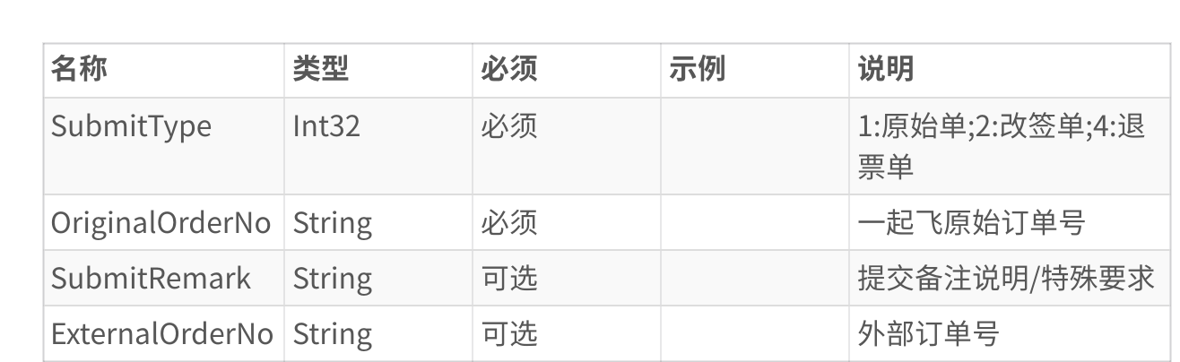

响应结果  
无

5. BizApi.OpenAPI.Shopping.VerifyCabin​  
验舱并补位接口  
请求参数

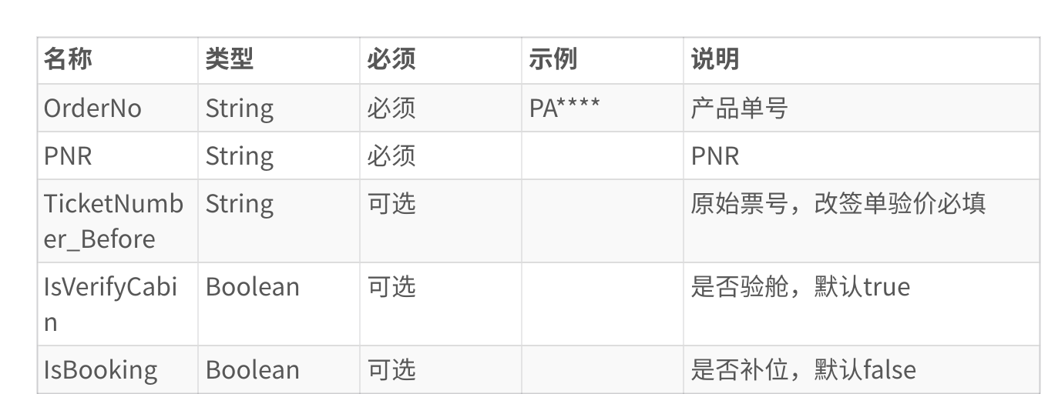

响应结果

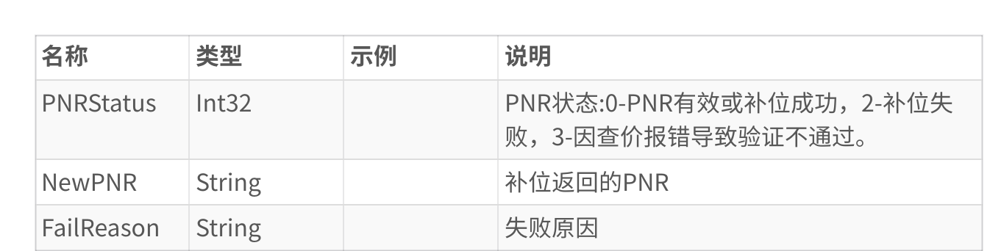

6. BizApi.OpenAPI.GetOrderList​  
请求参数

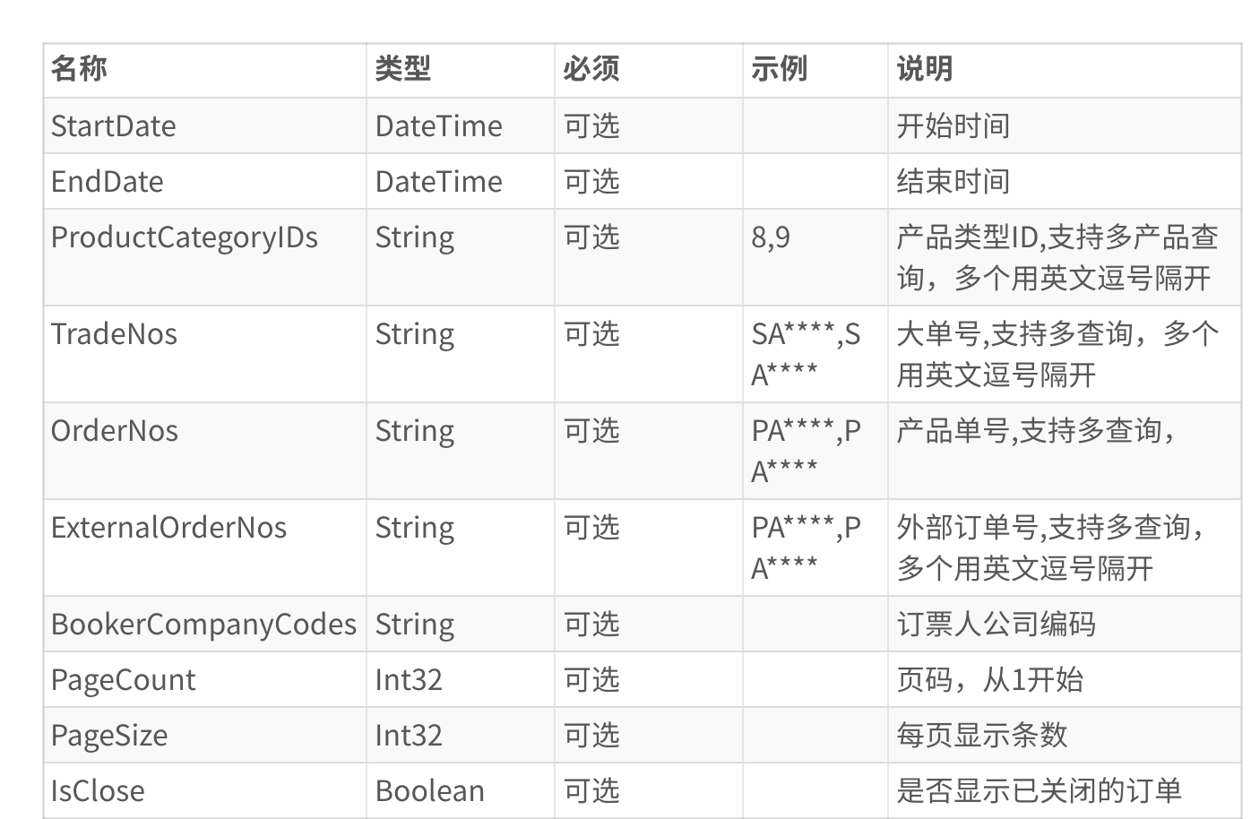

响应结果

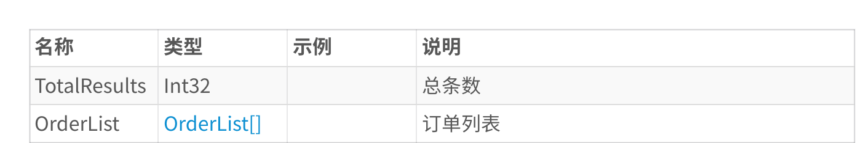

OrderList​

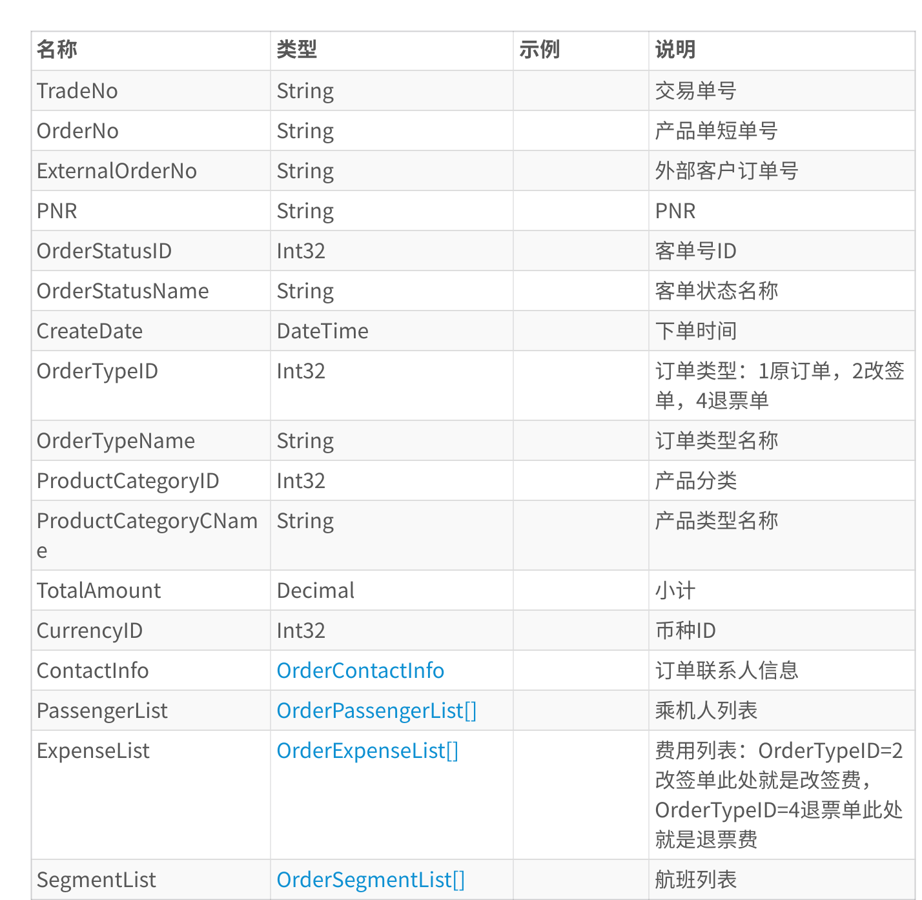

ContactInfo​

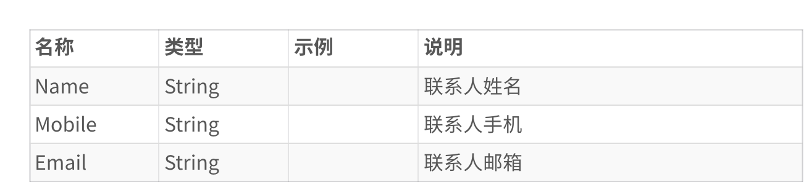

OrderPassengerList​

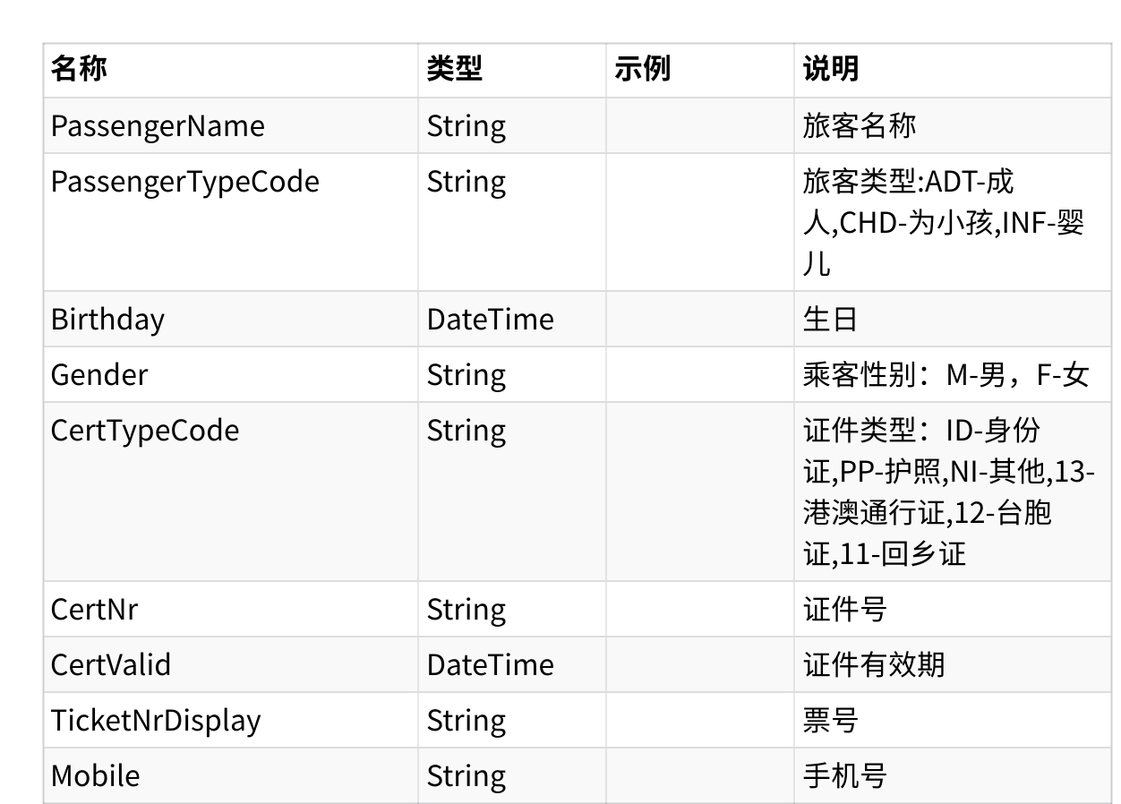

OrderExpenseList​

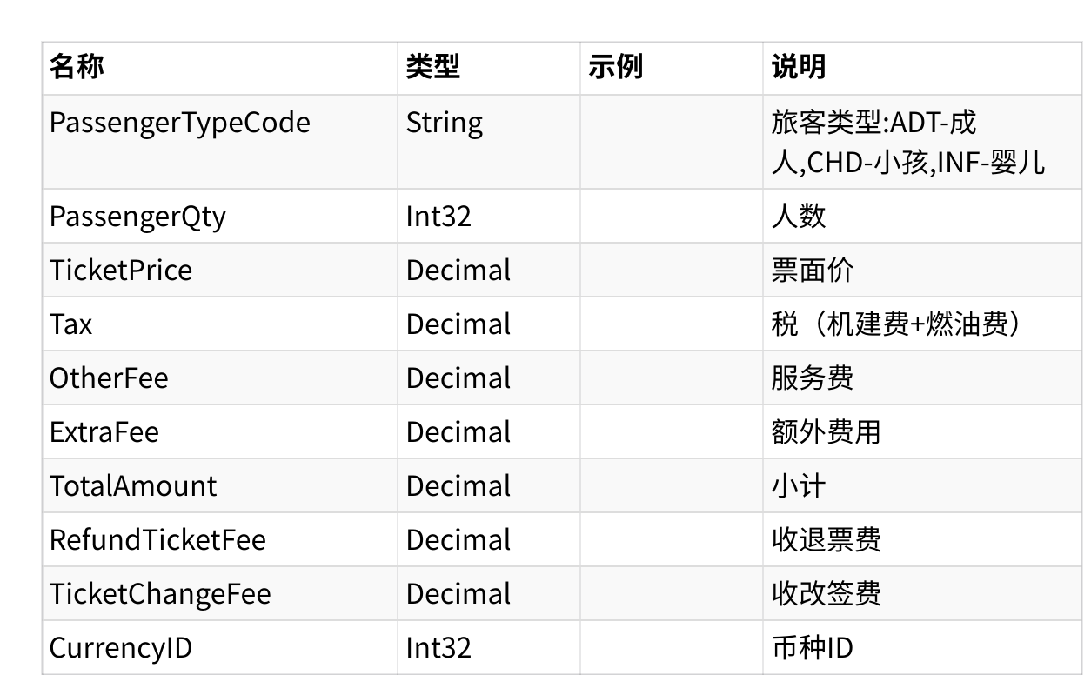

OrderSegmentList​

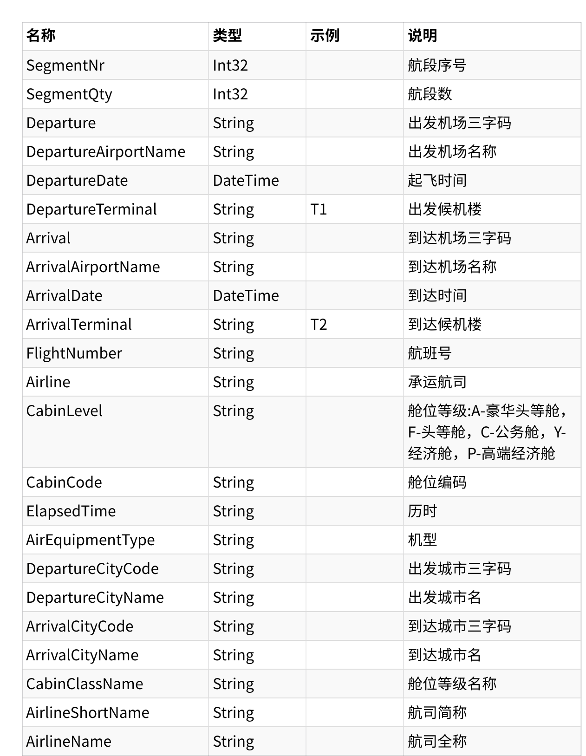

7. BizApi.AirTickets.Shopping.PNRCancelByPSONr​

请求参数

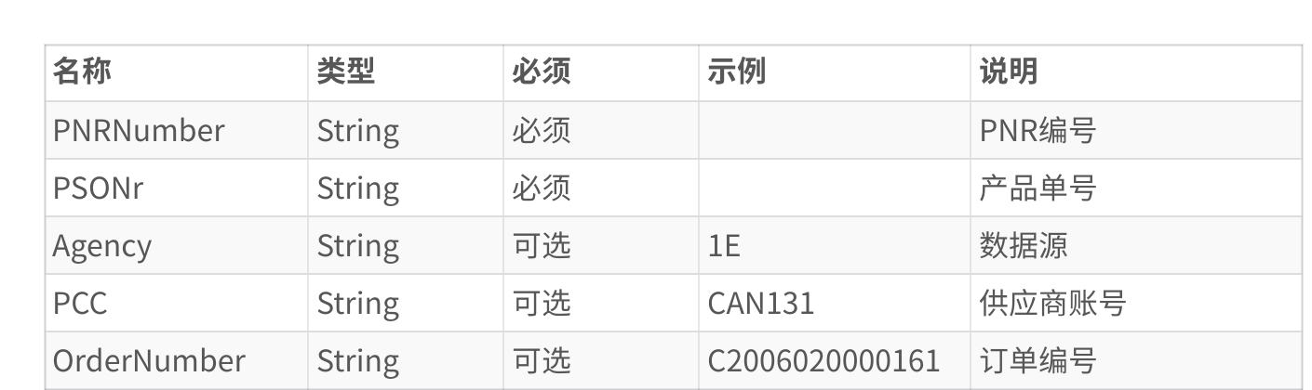

响应结果

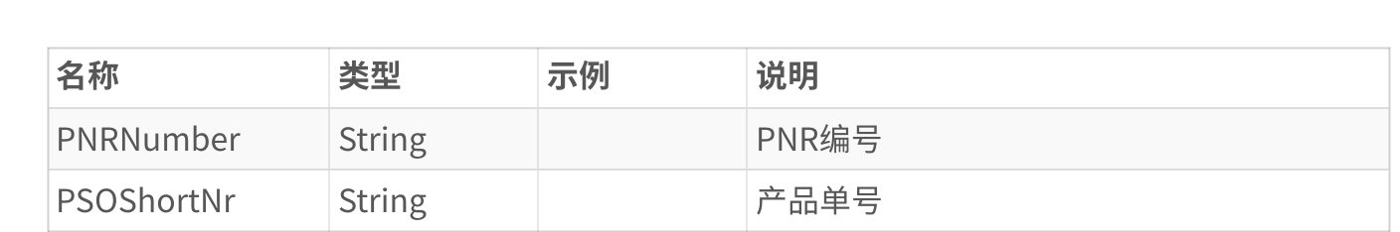

8. BizApi.OpenAPI.Shopping.AirReshopServing 改期航班查询​

请求参数

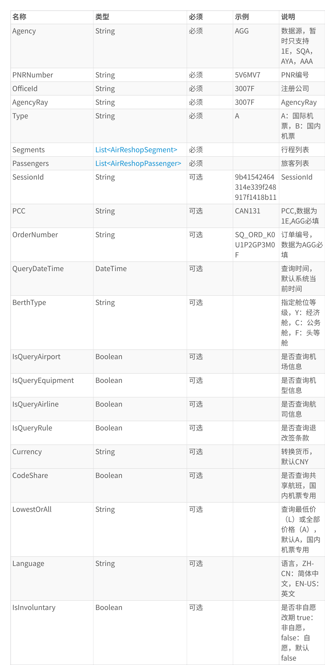



|  |  |  |
| --- | --- | --- |
|  | | |
| 1代码块​{   2   3   4   5   6   7   8   9  10  11  12  13  14  15  16  17  18  19  20  21  22  23  24  25  26  27  28  29  30  31  32  33  34 | | "OrderNumber": "SQ_ORD_K0U2RL******",   "Passengers": [  {   "OriginalTicketNumber": "618-2440810000", "FamilyName": "SAN",   "FirstName": "TAN",   "PassengerType": "ADT"  }  ],   "SessionId": "dd3941c5-4e33-44e9-ac61-e134eacc05ce", "Segments": [  {   "ChangeDepartureDate": "2023-01-27T00:00:00", "Legs": [  {   "FlightNumber": "882",   "Arrival": "HKG",   "DepartureDate": "2023/1/27 8:25:00", "Airline": "SQ",   "Cabin": "U",   "Departure": "SIN",   "ArrivalDate": "2023/1/27 12:25:00" }  ],   "IsChange": true  }  ],   "Agency": "SQA",   "AgencyRay": "BL00D",   "PCC": "CAN131",   "Type": "A",   "PNRNumber": "6XREL3",   "OfficeId": "21" |
| 35 | } |
|  | | |

响应结果













JourneyBiz​

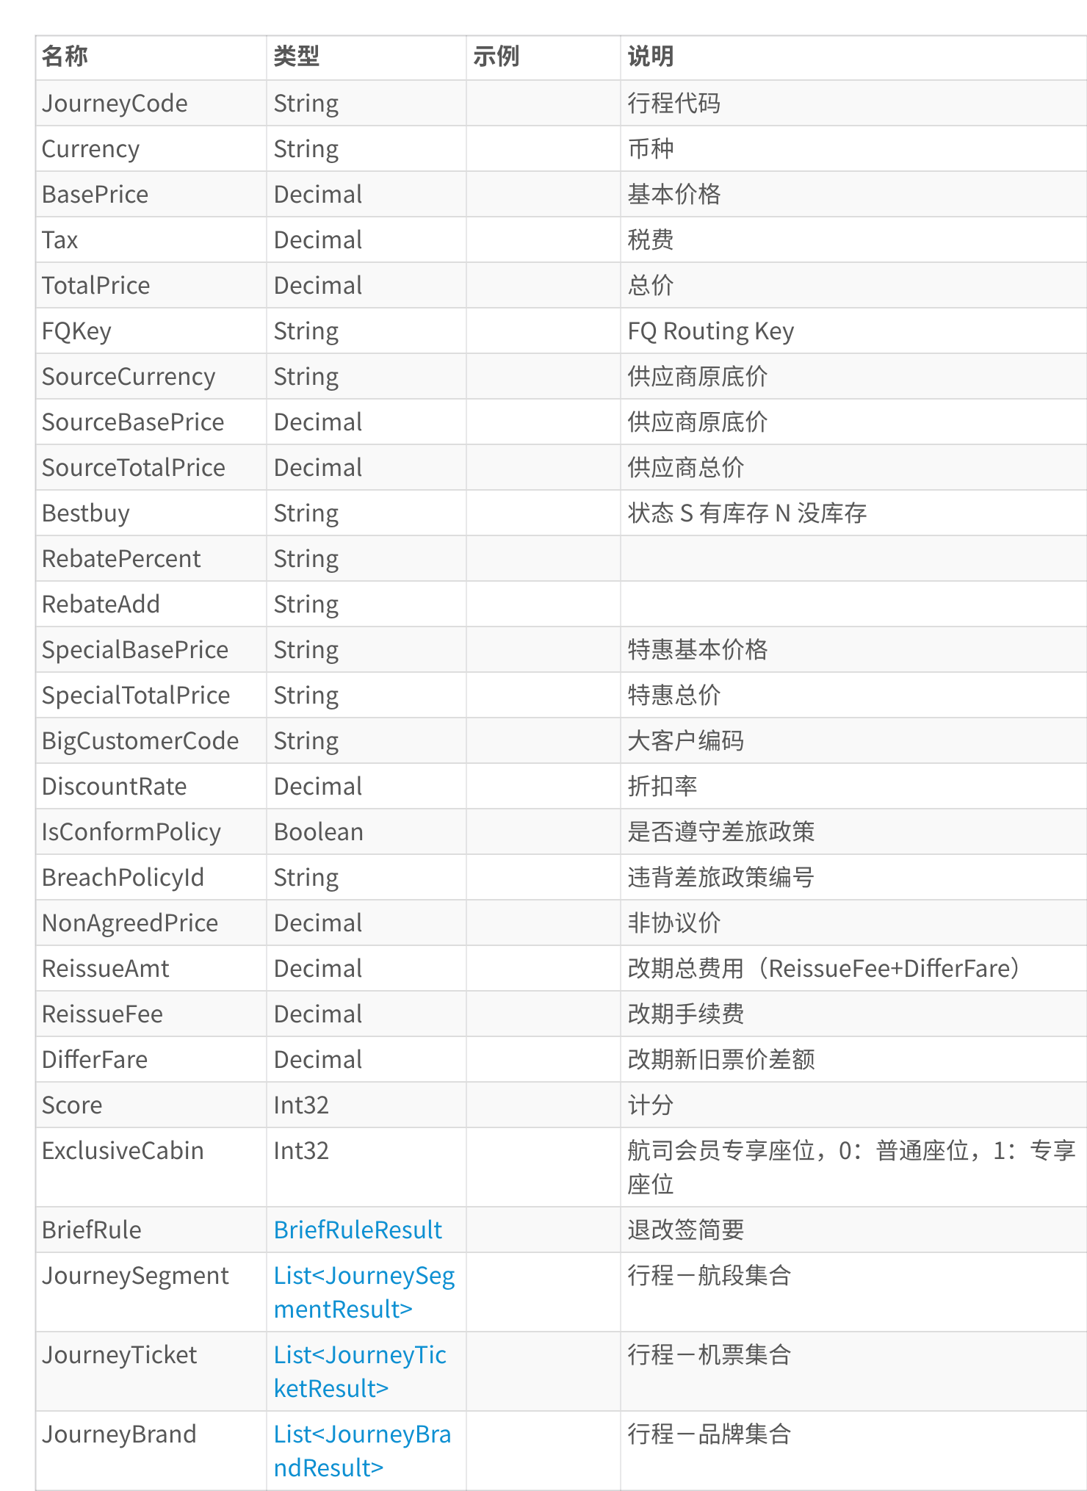

BriefRuleResult​



JourneySegmentResult​



JourneyTicketResult​



TicketAgencyResult​



TicketPricingResult​



TicketFareResult​



TicketFareFlightResult​

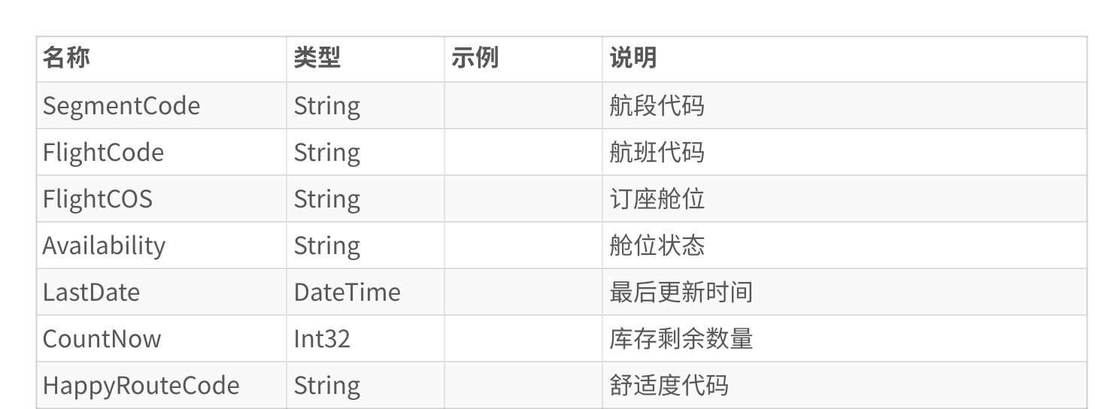

JourneyBrandResult​



9. BizApi.AirTickets.Shopping.AirRefundPriceServing 查询退票费​

请求参数

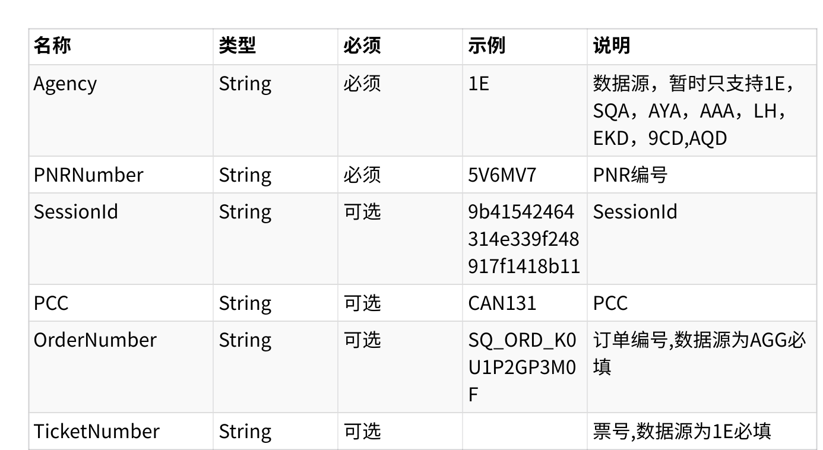

响应结果

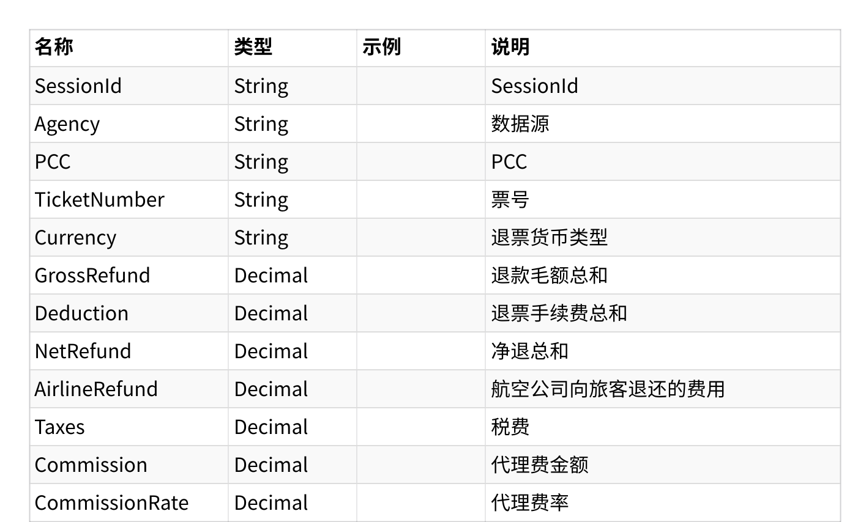

10. BizApi.AirTickets.Shopping.GetFareRuleDetailServing 获取退改条款​

请求参数

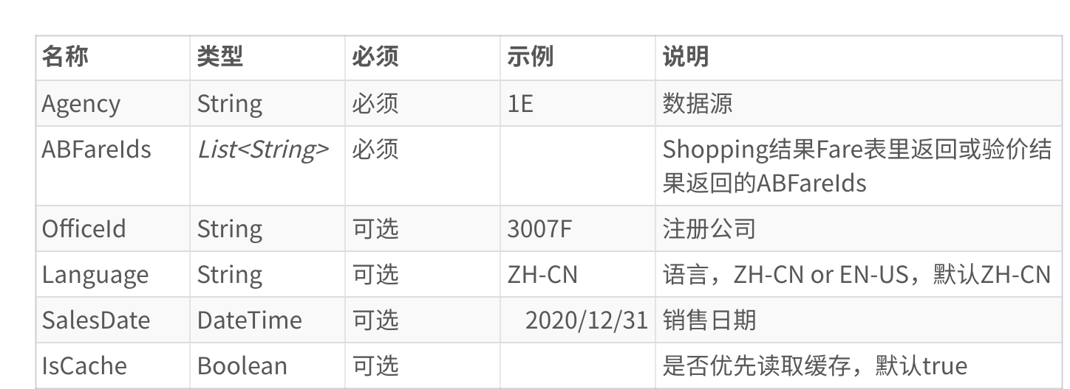

响应结果

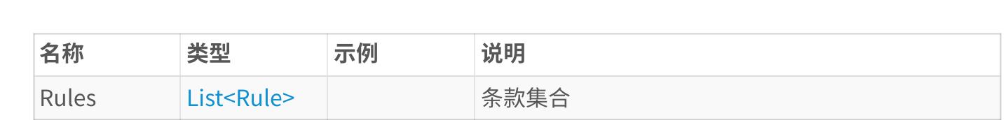

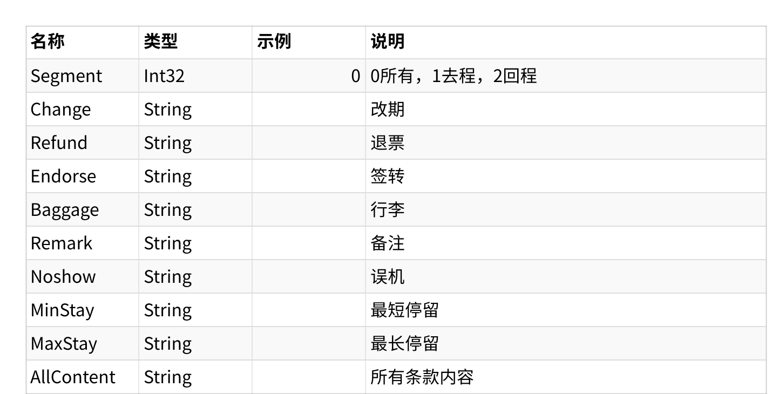

11. BizApi.OpenAPI.Dest.GetAirportList 获取全球机场信息​

说明

根据国家编码获取机场列表

请求参数

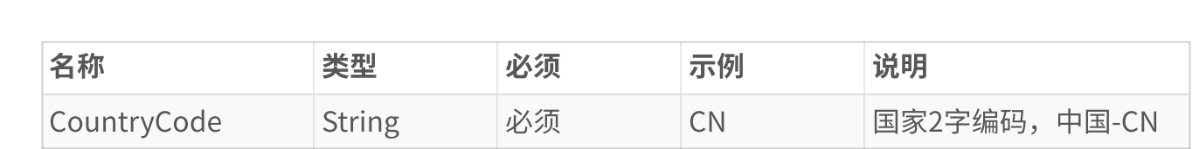

响应结果

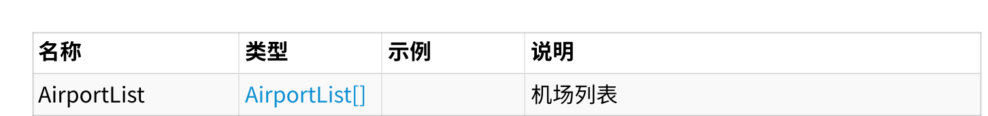

AirportList​

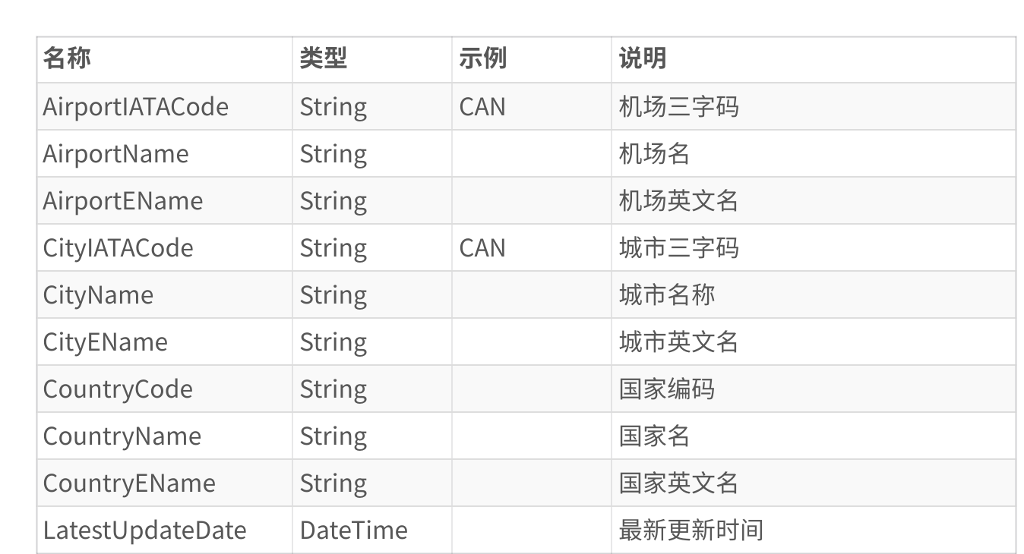

（内容由AI生成，仅供参考）